Task C-2A: Nutrient sampling for agricultural runoff BMP demonstration project.

Overall description of work
WRRC staff prepared quality assurance plan for nutrient sampling to evaluate effectiveness of agricultural BMPs in reducing phosphorus runoff into tributary of Mill River. This was done as part of the QAPP written for task A-1. Staff sampled above and below selected operation (i.e. UMass Hadley/Horse Farm).

All sampling has been successfully completed. In 2009, prior to installation of the BMPs, four dry weather and three wet weather samples each were taken at two locations: where a stream enters the farm (site HF1) and where it leaves the farm (site HF2). In 2012, after installation of BMPs was complete, three wet weather and three dry weather samples were taken at the same location. Samples were analyzed at UMass Environmental Analysis Laboratory for total phosphorus (listed as TPH in the accompanying map). Results have been posted on project web site and incorporated into a mobile tour of the Hadley Farm (see Task D). Need to update this map.

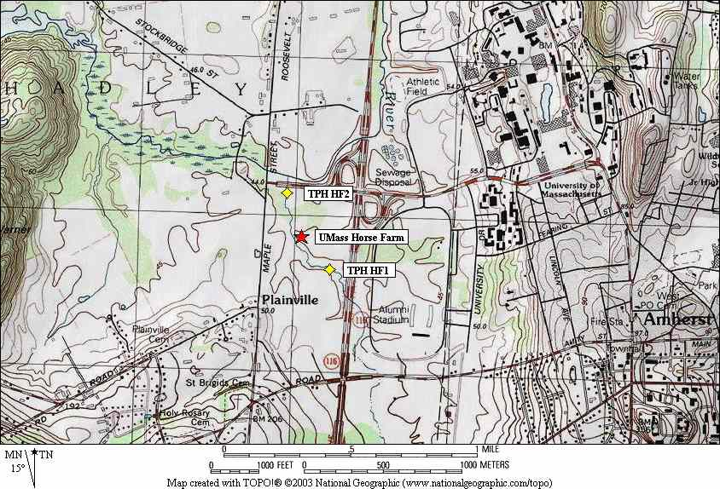

Map of farm and sampling locations.

Results
Total Phosphorus results, microns/liter (μ/l).
HF1 = upstream (entering farm); HF2 = downstream (leaving farm).
Date | HF1 | HF2
7/10/2009 | 35.5 | 36
8/14/2009 | 29.6 | 50.4
8/20/2009 | 22.8 | 92.1
9/10/2009 | 39.3 | 96.2
9/12/2009 | 57.7 | 87.7
9/28/2009 | 44 | 47.2
10/28/2009 | 124.1 | 23.9
8/27/2012 | 94.6 | 104.4
10/12/2012 | 48.5 | 63.2
10/26/2012 | 54.4 | 64.2
8/28/2012 | 82.8 | 408.2
9/5/2012 | 108.3 | 242.6
10/30/2012 | 91.6 | 124

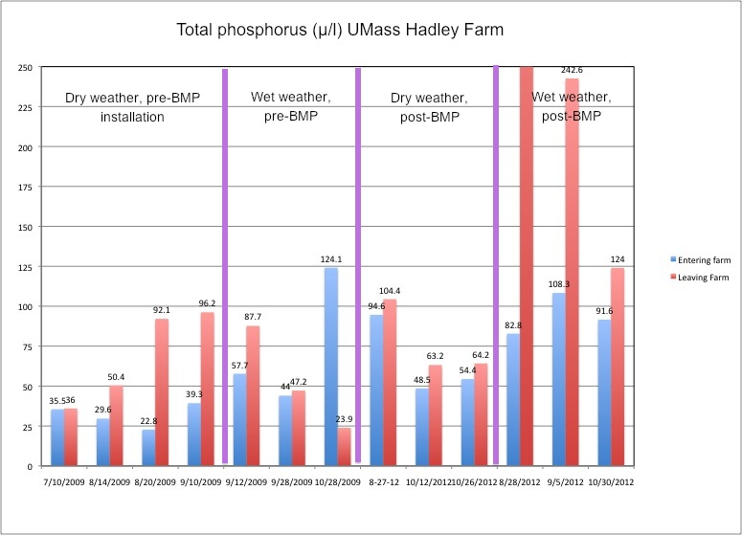
Results, all sampling dates.

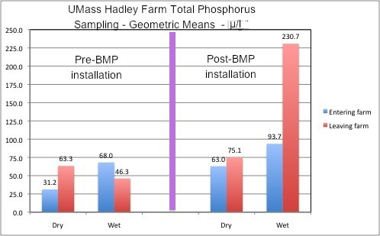
Geometric mean of wet and dry event sampling, pre- and post-BMP installation

Discussion of results.
In the pre-BMP installation data set, one sample pair merits discussion. On October 28, 2009, sampling after a heavy rainstorm, influent total phosphorus (TP) levels were 124.1μ/l, effluent levels were 23.9 μ/l. This sample pair differs from all other pre-BMP wet or dry weather results in that the influent concentration was considerably higher than any other sample date, and influent concentrations were considerably higher than effluent concentrations. The influent result isn’t called into question. Rainfall intensity and depth (1.65”) on that day affected effluent results in a way not seen on any other sampling event in this study. A vegetated swale runs east-west across the farm from North Maple Street to the west, and connects to the stream within a few yards of the effluent sampling point. On this date, rainfall totals were sufficient to flood this swale and the entire area near the effluent sampling point. Water was between 3 and 4 feet deep at this point. The swale drained a large area, including unused pastures to the west of North Maple street. We conjecture that this area likely contributed clean water (i.e. low in phosphorus), thereby depressing levels at the sampling location enough to produce anomalous results. This outlier influenced the geometric mean of pre-BMP sample results to some degree. Including all three wet weather pre-installation wet weather dates, the geometric influent and effluent results were 68 and 46.3 μ/l, respectively. If we remove the 10/28 storm from the dataset, average concentrations for the two remaining storm events were 50.9 and 67.5 μ/l for influent and effluent sampling points. We view this as the more reliable indicator of the farm’s impact on nutrient levels. It suggests a modest increase in total phosphorus concentrations, as does the dry weather data.

Results from samples taken after the installation of the BMPs suggest that the BMPs were not effective in reducing total phosphorus levels in the stream. If anything, conditions worsened. There are eight sets of conditions: four pre BMP installation sets (wet weather and dry weather, upstream and downstream) and the same four sets for post-BMP installation. Looking at the graph of geometric means for all conditions, it is apparent that the farm contributed to a modest increase is phosphorus levels for both dry and wet conditions prior to installation of the BMPs (leaving out the 10/28/2009 storm for this analysis) and for dry conditions after BMPs were installed. It appears to have contributed to significantly higher phosphorus levels during wet weather conditions. It is also noteworthy that under all circumstances – upstream and down, dry and wet weather, phosphorus levels were higher than prior to installation of the BMPs. This suggests there may be other factors at play – e.g. changes in land use or nutrient management practices anywhere in the contributing watershed. Investigation of such possible influences is beyond the scope of this study.
Another factor that may have compromised the ability to demonstrate water quality improvements from the BMPs is location of HF1, the upstream sampling point. It was known at project start that this was an imperfect sampling location, because the stream only flows through the northern and eastern portions of the farm. The southwestern part of the farm receives flow only during storm events (i.e. no perennial streams there); this flow comes from the southwest, via a different sub-basin than that drained by the stream. This means that there may be conditions both within the farm and “upstream” (to the southwest) that affect nutrient levels at HF2, but which are not related to HF1. Hence we do not have a straightforward control site/impact site comparison, as is preferable. HF1 was selected as the upstream sampling point because it is the only point where there is a constant flow of water entering the farm. Under dry conditions, it is not practical to gather influent nutrient samples from any other point. We cannot therefore conclusively state that the BMPs were entirely ineffective. They may have in fact reduced phosphorus pollutant loads that were not accounted for by sampling HF1. We can state that the BMPs did not appear to reduce total phosphorus in the stream between the point it entered and the point it left the farm.

Task goals
Provide general statement about project goals.
Characterize phosphorus pollution coming from farm prior to and after installation of BMPs, via total phosphorus sampling/analysis.

Describe how you met each of the following goals for the project.
This goal was accomplished by sampling and analysis discussed above.

Performance measures
Provide general statement about project performance measures.
Performance measures outlined in QAPP – number of samples collected, quality control activities performed (duplicate field samples analyzed at lab).

Describe how you met each of the following performance measures for the project.
Ten quality control samples were taken. These consisted of field duplicates.

Date | Site | Field | Duplicate | RPD
9/10/2009 | HF2 | 96.2 | 85.8 | 11.4%
9/12/2009 | HF1 | 57.7 | 55.7 | 3.5%
9/28/2009 | HF1 | 44 | 56.5 | 24.9%
10/28/2009 | HF1 | 124.1 | 97 | 24.5%
8/27/2012 | HF1 | 94.6 | 104.4 | 9.8%
8/28/2012 | HF2 | 408.2 | 386.1 | 5.6%
9/5/2012 | HF2 | 242.6 | 230.7 | 5.0%
10/12/2012 | HF1 | 48.5 | 25 | 63.9%
10/26/2012 | HF2 | 64.2 | 63.2 | 1.6%
10/30/2012 | HF2 | 124 | 128.9 | 3.9%
Quality Control Results. Field and duplicate units are μ/l.

RPD = relative per cent difference, comparing the field sample vs. the duplicate, or QC sample. Three samples showed undesirably high RPDs; those taken on September 28 and October 28, 2009 and October 12, 2012. These are flagged, but not discarded. On one occasion, September 28, 2009, replacing the field value (44 μ/l) with the QC (56.5 μ/l) value would have resulted in the upstream (HF1) value being greater than the downstream (HF2) value of 47.2 μ/l. Using either value, the change in phosphorus levels from upstream to downstream sites was relatively minor. In the other two cases of high RPDs (October 28, 2009 and October 12, 2012) switching the field and QC results would still result in the expected increase in phosphorus from upstream to downstream.

Deliverables
Provide general statement about project deliverables.
Deliverables for this task were all met in a satisfactory manner, according to timeline established in project work plan.

Describe how you achieved each of the following project deliverables.
WRRC staff collected samples, delivered to the UMass Environmental Analytical Lab (EAL) according to sample collecting, preservation and transport methods and chain of custody procedures described in the QAPP. EAL staff preserved and analyzed samples according to quality assurance plan.

Environmental Outcomes
Provide general statement about environmental outcomes.
Outcomes are described in discussion section. It does not appear that the BMPs installed reduced total phosphorus levels in the Mill River when comparing data from the point where the stream enters the farm to where it leaves the farm.

Describe how you achieved each of the following project environmental outcomes.
See above.
Budget
Provide any information related to the budget you think important to the final report, particularly any additional funding that may have been leveraged through the work of this grant.

Lessons Learned
Describe any lessons learned in the course of the work for this project that will help to inform and direct future work.
The sampling went according to plan. As discussed above, there was initial concern about the limited options for locating sampling points. Sampling at site HF1 did not allow us to measure pollutant loads accumulating on dry land in the southwest portion of the farm and entering the stream during runoff events. This initial concern proved valid, as sampling results did not conclusively answer the question of whether BMPs installed would reduce nutrient pollution coming from the farm. Other than selecting another agricultural operation entirely, or by employing a very different and much more complicated and expensive sampling protocol involving dry land nutrient sampling, it is difficult to see how the problem could have been avoided.

