WATERSHED-BASED PLAN
Mill River Watershed within
the Towns of Hadley, Amherst, Sunderland, Leverett, and Shutesbury
December 2019

Prepared By:
University of Massachusetts
Geosyntec Consultants, Inc.

Prepared For:

This project has been financed with Federal Funds from the Environmental Protection Agency (EPA) to the Massachusetts Department of Environmental Protection (the Department) under an s. 319 competitive grant. The contents do not necessarily reflect the views and policies of EPA or of the Department, nor does the mention of trade names or commercial products constitute endorsement or recommendation for use

Contents
Executive Summary i
Introduction 1
Purpose & Need 1
Watershed-Based Plan Outline 1
Project Partners and Stakeholder Input 2
Data Sources 2
Summary of Past and Ongoing Work 2
Element A: Identify Causes of Impairment & Pollution Sources 4
General Watershed Information 4
MassDEP Water Quality Assessment Report and TMDL Review 6
Water Quality Impairments 20
Additional Water Quality Data 21
Water Quality Goals 22
Land Use Information 24
Pollutant Loading 29
Element B: Determine Pollutant Load Reductions Needed to Achieve Water Quality Goals 31
Estimated Pollutant Loads 31
Water Quality Goals 31
Element C: Describe management measures that will be implemented to achieve water quality goals 34
Existing Management Measures 34
Ongoing Management Measures 34
Future Management Measures 35
Element D: Identify Technical and Financial Assistance Needed to Implement Plan 37
Current and Ongoing Management Measures 37
Future Management Measures 38
Element E: Public Information and Education 39
Elements F & G: Implementation Schedule and Measurable Milestones 41
Elements H & I: Progress Evaluation Criteria and Monitoring 42
Indirect Indicators of Load Reduction 42
Project-Specific Indicators 44
TMDL Criteria 44
Direct Measurements 44
Adaptive Management 44
References 46

Executive Summary
Introduction: The purpose of a Massachusetts Watershed-Based Plan (WBP) is to organize information about Massachusetts' watersheds, and present it in a format that will enhance the development and implementation of projects that will restore water quality and beneficial uses in the Commonwealth. The Massachusetts WBP follows USEPA's recommended format for “nine-element” watershed plans. This WBP was developed by Geosyntec Consultants (Geosyntec) under the direction of the University of Massachusetts, Amherst with funding, input, and collaboration from the Massachusetts Department of Environmental Protection (MassDEP).
This WBP was prepared for the approximately 30-square mile Mill River watershed, which is a tributary to the Connecticut River. Major streams in the watershed include the Mill River (MA34-25); Cushman Brook (MA34-34); Doolittle Brook; Mountain Brook; Nurse Brook (MA34-59) and Roaring Brook. Major lakes and ponds in the watershed include Lake Warner (MA34098) and Puffers Pond.
Impairments and Pollution Sources: The Mill River (MA34-25), which flows from Puffers Pond in Amherst to Lake Warner in Hadley, is a category 5 water body on the Massachusetts List of Integrated Waters (303(d) list) due to Escherichia coli (E. coli) from agriculture, unknown sources, and urban stormwater runoff.
Lake Warner (MA34098) has a completed Phosphorus Total Maximum Daily Load (TMDL) and is a category 4A water body on the Massachusetts List of Integrated Waters due to excess algal growth, non-native aquatic plants, dissolved oxygen, total phosphorus (TP), and turbidity due to introduction of non-native organisms and unknown sources.
Full of Grace Farm is a 20-acre equine farm located in Hadley, MA, which currently houses 15-17 horses, was identified as a major impairment source within the watershed. The equine facility is located directly on top of wetlands and the Mill River runs through the property. Horses have direct access to the Mill River. There is visible leaching and runoff from the on-site manure pile, and there currently are no stormwater management measures being implemented on the property.
E. coli samples collected between April—November 2003 from the Mill River at Mill River Lane in Hadley (approximately 600 feet downstream of the Full of Grace Farm property) had a geometric mean of 148 colonies/100 ml, which is above the Massachusetts Surface Water Quality Standard of 126 colonies/ 100 ml (MassDEP 2003). E. coli samples were collected from May—September 2008 at the same location and revealed a geometric mean of 171 colonies/ 100 ml (MassDEP 2008). Total Phosphorus (TP) samples collected from May—September 2008 ranged from 14—77 ug/l with an average of 36 ug/L.
E. coli data obtained from approximately 1/4-mile upstream of where the Mill River enters Lake Warner (collected by the “Friends of Lake Warner and the Mill River”) was collected in 2017, 2018, and 2019 and had a geometric mean of 392, 772 and 480 colonies/ 100 ml, respectively (Johnson, 2019), which is substantially above the Massachusetts Surface Water Quality Standard of 126 colonies/ 100 ml (MassDEP 2003). TP data was also collected at this location in 2003, 2015, 2018 and 2019 and had an average of 71 ug/l of TP (Johnson, 2019), which is above the water quality criteria of 50 ug/L (USEPA 1986).
Goals, Management Measures, and Funding: The primary goal of this WBP is to reduce E. coli and nutrient (Total Phosphorus) loading to the Mill River, eventually leading to delisting of impaired waterbodies in the study area from the 303(d) list. It is expected that these pollutant load reductions will result in improvements to listed impairments throughout the study area.
It is expected that goals will be accomplished primarily through installation of structural BMPs to capture runoff and reduce loading as well as implementation of non-structural BMPs (e.g., street sweeping, catch basin cleaning), and watershed education and outreach. Structural BMPs will first be implemented at the Full of Grace Farm in Hadley per Fiscal Year 2020 Section 319 grants. Additional planning and implementation is expected to be performed in subsequent years, focusing on each water body in the study area.
It is expected that funding for management measures will be obtained from a variety of sources including Section 319 Grant Funding, Town capital funds, volunteer efforts, and other sources.
Public Education and Outreach: Goals of public education and outreach are to provide information about proposed stormwater improvements and their anticipated benefits and to promote watershed stewardship. The University of Massachusetts aims to engage the equine industry and community horse owners by hosting an annual field day at the proposed project, including the generation of educational materials and subsequent follow up discussion with interested attendees. It is expected that this program will be evaluated by tracking field day attendance. The University of Massachusetts-Amherst plans to distribute fact sheets and newsletters to an email list serve of over 800 relevant parties and post news of the project on the “Crops, Dairy, Livestock and Equine” UMass Extension webpage. It is expected that this program will be evaluated by tracking the number of emails and the size of the list serve receiving the emails in addition to visitors to the UMass Extension webpage.
Implementation Schedule and Evaluation Criteria: Project activities will be implemented based on the information outlined in the following elements for monitoring, implementation of structural BMPs, public education and outreach activities, and periodic updates to the WBP. It is expected that a water quality monitoring program will enable direct evaluation of improvements over time. Other indirect evaluation metrics are also recommended, included quantification of potential pollutant load reductions from non-structural BMPs (e.g., street sweeping). The long-term goal of this WBP is to de-list the all waterbodies within the study area from the 303(d) list by 2035. The WBP will be re-evaluated and adjusted, as needed, once every three years.

Introduction
What is a Watershed-Based Plan?

Purpose & Need
The purpose of a Massachusetts Watershed-Based Plan (WBP) is to organize information about Massachusetts' watersheds, and present it in a format that will enhance the development and implementation of projects that will restore water quality and beneficial uses in the Commonwealth. The Massachusetts WBP follows USEPA's recommended format for “nine-element” watershed plans, as described below.
All states are required to develop WBPs, but not all states have taken the same approach. Most states develop watershed-based plans only for selected watersheds. MassDEP's approach has been to develop a tool to support statewide development of WBPs, so that good projects in all areas of the state may be eligible for federal watershed implementation grant funds under Section 319 of the Clean Water Act.
USEPA guidelines promote the use of Section 319 funding for developing and implementing WBPs. WBPs are required for all projects implemented with Section 319 funds, and are recommended for all watershed projects, whether they are designed to protect unimpaired waters, restore impaired waters, or both.

Watershed-Based Plan Outline
This WBP for the Mill River Watershed includes nine elements (a through i) in accordance with USEPA Guidelines:
- An identification of the causes and sources or groups of similar sources that will need to be controlled to achieve the load reductions estimated in this watershed-based plan (and to achieve any other watershed goals identified in the watershed-based plan), as discussed in item (b) immediately below.
- An estimate of the load reductions expected for the management measures described under paragraph (c) below (recognizing the natural variability and the difficulty in precisely predicting the performance of management measures over time).
- A description of the nonpoint source (NPS) management measures needed to achieve the load reductions estimated under paragraph (b) above (as well as to achieve other watershed goals identified in this watershed-based plan), and an identification (using a map or a description) of the critical areas in which those measures will be needed to implement this plan.
- An estimate of the amounts of technical and financial assistance needed, associated costs, and/or the sources and authorities that will be relied upon, to implement this plan. As sources of funding, States should consider the use of their Section 319 programs, State Revolving Funds, USDA's Environmental Quality Incentives Program and Conservation Reserve Program, and other relevant Federal, State, local and private funds that may be available to assist in implementing this plan.
- An information/education component that will be used to enhance public understanding of the project and encourage their early and continued participation in selecting, designing, and implementing the NPS management measures that will be implemented.
- A schedule for implementing the NPS management measures identified in this plan that is reasonably expeditious.
- A description of interim, measurable milestones for determining whether NPS management measures or other control actions are being implemented.
- A set of criteria to determine if loading reductions are being achieved over time and substantial progress is being made towards attaining water quality standards and, if not, the criteria for determining whether this watershed-based plan needs to be revised or, if a NPS Total Maximum Daily Load (TMDL) has been established, whether the TMDL needs to be revised.
- A monitoring component to evaluate the effectiveness of the implementation efforts over time, measured against the criteria established under item (h) immediately above.

Project Partners and Stakeholder Input
This WBP was developed by Geosyntec Consultants (Geosyntec) under the direction of the University of Massachusetts, Amherst with funding, input, and collaboration from the Massachusetts Department of Environmental Protection (MassDEP). This WBP was developed using funds from the Section 319 program to assist grantees in developing technically robust WBPs using MassDEP’s Watershed-Based Planning Tool. The University of Massachusetts, Amherst was a recipient of Section 319 funding in Fiscal Year 2020 to implement BMPs in the Mill River Watershed.
Core project stakeholders included:
- Mousoud Hashemi – University of Massachusetts, Amherst
- Timothy Randhir – University of Massachusetts, Amherst
- Cassandra Uricchio – University of Massachusetts, Amherst
- Matthew Reardon – MassDEP
This WBP was developed as part of an iterative process. The Geosyntec project team collected and reviewed existing data from the University of Massachusetts. This information was then used to develop a preliminary WBP for review by core project stakeholders. A stakeholder conference call was then held to solicit input and gain consensus on elements included in the plan (e.g., water quality goals, public outreach activities, etc.). The WBP was finalized once stakeholder consensus was obtained for all elements.

Data Sources
This WBP was developed using the framework and data sources provided by MassDEP’s Watershed-Based Plan Tool and supplemented by information provided in the Section 319 Nonpoint Source Pollution Grant Program application for “Implementation, Remediation, and Education of Selected Best Management Practices to Minimize the Environmental Impact of Two Equine Operations” (University of Massachusetts, 2019).

Summary of Past and Ongoing Work
The University of Massachusetts has successfully implemented the following Section 319 grant-funded agricultural BMP improvements in the Mill River watershed.

UMass Horse Farm
The following BMPs were implemented:
- Several sacrifice areas with a total area of 28,800 square feet;
- Vegetated swales were constructed;
- Fencing was installed to exclude horses from wetlands;
- Approximately 32,000 square feet of pasture was reseeded; and
- An aerated composting system was installed.

Mapleline Dairy Farm
Based on soil tests, most of the fields on this farm used for growing corn silage needed additional Nitrogen, but had excess Phosphate being applied. An updated Comprehensive Nutrient Management Plan was developed for this farm and implemented in August 2017.

Jonathan Carr Farm
Cover crop was applied to approximately twenty acres of farm land and brush management was implemented on approximately 13 acres of farmland for erosion control. These BMPs were implemented in July 2017—April 2018.

Devine Dairy Farm
Leachate was controlled from silage bunks with a vegetative treatment area, and an existing bunk silo was reconstructed to increase proper storage capacity of corn silage. These BMPs were implemented in June 2018 and September 2017, respectively.

Adriance Farm
An aerated compost pile was constructed and implemented in August 2017 to treat manure from three donkeys and 4 alpacas at the farm.

Element A: Identify Causes of Impairment & Pollution Sources
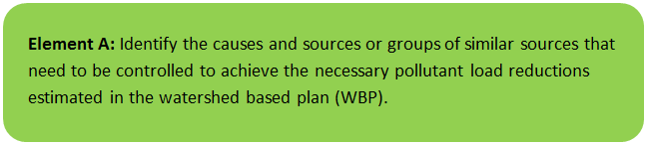

General Watershed Information
This WBP was prepared for the Mill River watershed, which is located in the towns of Hadley, Amherst, Leverett, Sunderland and Shutesbury, Massachusetts, and was delineated to the outlet of Lake Warner in Hadley Massachusetts. Major streams in the watershed include the Mill River (MA34-25); Cushman Brook (MA34-34); Doolittle Brook; Mountain Brook; Nurse Brook and Roaring Brook. Lake Warner (MA34098), Puffers Pond, Leverett Pond (MA34042), and Atkins Reservoir are also included in the watershed. The Mill River is a tributary to the Connecticut River, and has a drainage area of approximately 19,500 acres (approximately 30 square miles).
Table A-1 presents the general watershed information for the Mill River watershed and Figure A-1 includes a map of the watershed boundary.
Table A-1: General Watershed Information
Watershed Name (Assessment Unit ID): | Cushman Brook (MA34-34); Doolittle Brook; Mill River (MA34-25); Mountain Brook; Nurse Brook; Roaring Brook; Lake Warner (MA34098); Puffers Pond, Leverett Pond (MA34042), Atkins Reservoir
Major Basin: | Connecticut River
Watershed Area (within MA): | 19,464 acres

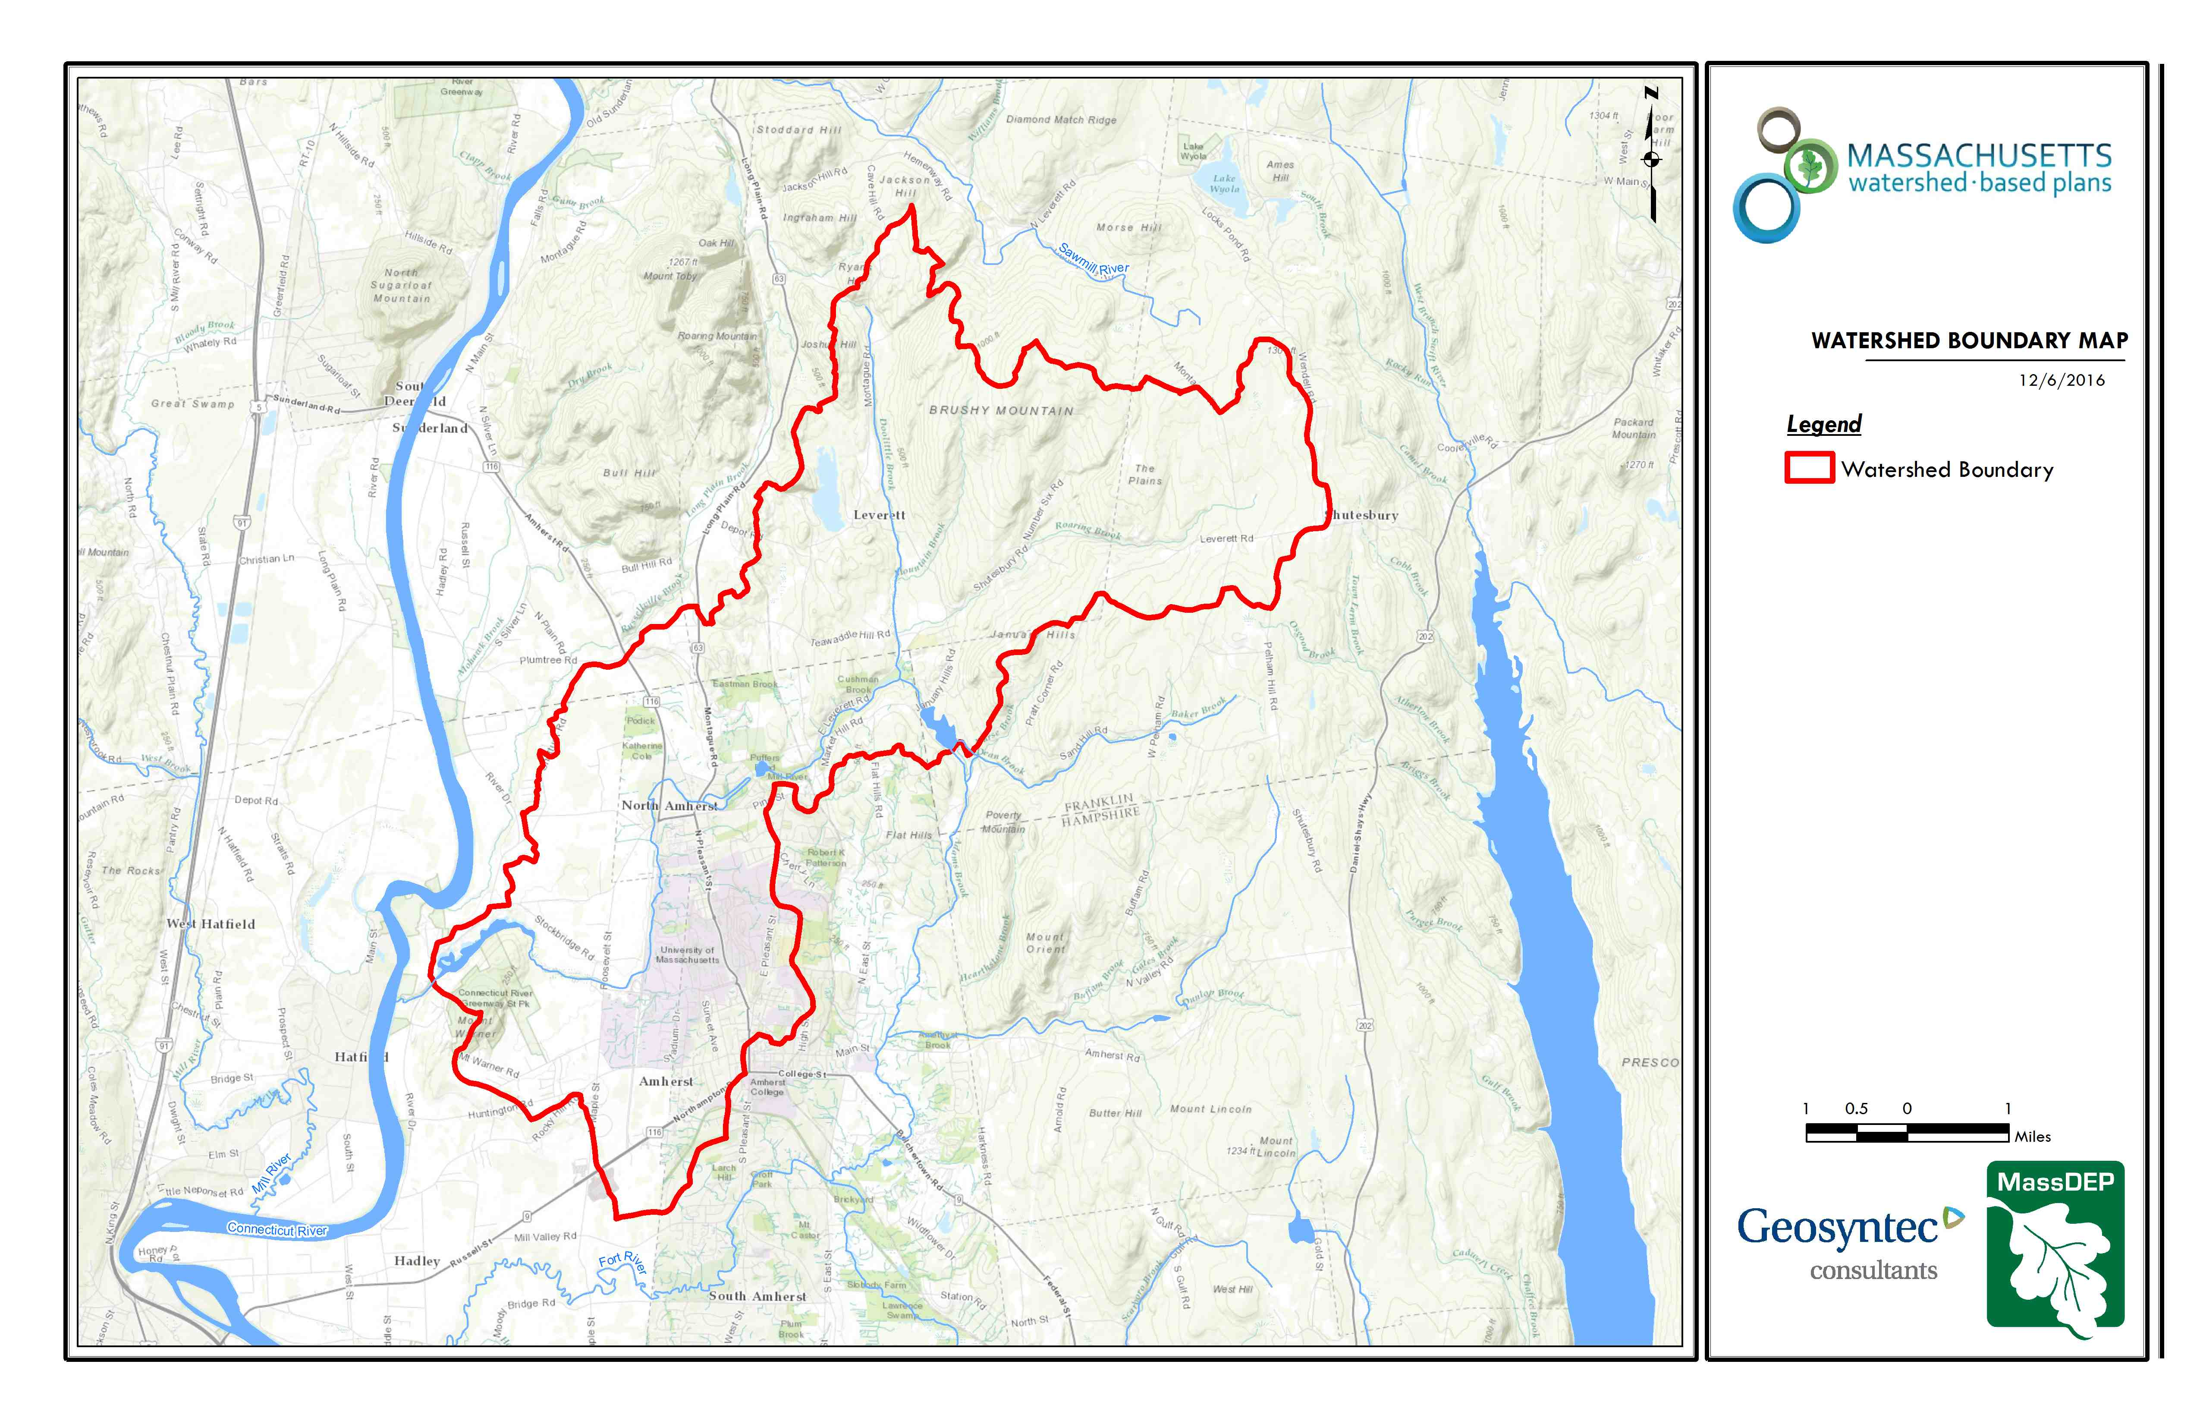
Leverett Pond
Puffers Pond
Lake Warner
Mill River
Figure A-1: Watershed Boundary Map
(MassGIS, 2007; MassGIS, 1999; MassGIS, 2001; USGS, 2016)

MassDEP Water Quality Assessment Report and TMDL Review
The following reports are available:
- Connecticut River Watershed 2003 Water Quality Assessment Report
- Total Maximum Daily Loads of Phosphorus for Selected Connecticut Basin Lakes
- Connecticut River Watershed 2008 DWM Water Quality Monitoring Data
- Connecticut River Watershed 2008 Benthic Macroinvertebrate Bioassessment
Select excerpts from these documents relating to the water quality in Mill River (MA34-25), Cushman Brook (MA34-34), Lake Warner (MA34098), and Leverett Pond (MA34042) are included below (note: relevant information is included directly from these documents for informational purposes and has not been modified).
Connecticut River Watershed 2003 Water Quality Assessment Report (MA34-34 - Cushman Brook )
AQUATIC LIFE
Habitat/Flow
On 17 September 2003 DWM biologists conducted a habitat assessment of Cushman Brook at the south side of State Street in Amherst. Most of the habitat measures were found to be within the “optimal” range. The total habitat score arrived at for this fish population survey was 167/200 (Appendix D). DWM biologists also conducted a habitat assessment on Cushman Brook in conjunction with benthic macroinvertebrate sampling upstream from Factory Hollow Pond in Amherst in 2003. The total habitat score for Cushman Brook at that location was 154 / 200 (Appendix C).
Biology
DWM conducted benthic macroinvertebrate sampling in Cushman Brook at Station B0508, upstream from Factory Hollow Pond in Amherst on 22 July 2003. The total metric score for Cushman Brook is 86% comparable to the reference station (Amethyst Brook) in terms of community structure, resulting in an assessment of “non-impacted” (Appendix C).
DWM conducted fish population sampling in Cushman Brook, south side of State Street in Amherst on 17 September 2003 (Appendix D). Five fish species were collected from this station, including: 26 brown trout (multiple age classes), 13 blacknose dace, 1 brook trout, 1 white sucker, and 1 longnose dace. Pollution intolerant fluvial specialist/dependant species dominated the fish community.
This segment of Cushman Brook is assessed as support for the Aquatic Life Use based on the non-impacted benthic macroinvertebrate community and the fish community data.
PRIMARY AND SECONDARY CONTACT RECREATION AND AESTHETICS USES
No objectionable conditions were noted by the DWM biologists during the fish population or benthic macroinvertebrate surveys (Appendix C and Mitchell 2007).
Report Recommendations:
Conduct bacteria sampling to evaluate the Primary and Secondary Contact Recreation uses.

Connecticut River Watershed 2003 Water Quality Assessment Report (MA34-25 - Mill River-Hadley )
USE ASSESSMENT
AQUATIC LIFE
Habitat/Flow
The total habitat score recorded by DWM fisheries biologists for the Mill River – Hadley site in 2003 was 112 out of a possible 200. This is the poorest score of all stations examined in the Connecticut watershed in 2003 (Appendix D). Habitat was most limited by the poor epifaunal substrate score (no riffles were present). Scores were also suboptimal for embeddedness, sediment deposition, and velocity-depth combinations. These conditions were considered to be naturally occurring; the reach is within the Connecticut River Valley floor, is of relatively low gradient, and has a sandy bottom.
Biology
DWM conducted fish population sampling in the Mill River - Hadley, East of Route 116 in Amherst on 17 September 2003. Only 15 fish were captured during the survey, representing eight species. However, electro-fishing efficiency was rated as “poor,” and due to the depth and width of the stream some fish were not captured (Appendix D). The fish community was dominated by moderately pollution tolerant fluvial specialist/dependant species.
Chemistry - water
DWM conducted water quality sampling at Mill River Lane in Hadley, Station 25C, on this segment of the Mill River - Hadley between April and October 2003 (Appendix B and E). All measurements were indicative of good water quality conditions.
This segment of Mill River - Hadley is assessed as support for the Aquatic Life Use based on the good water quality data. The poor collection efficiency noted with the fish community data makes it difficult to determine if the low numbers of fish collected are truly representative of the fish community present at that location. The low habitat score is a concern but is naturally occurring and does not overrule the good water quality data.
PRIMARY AND SECONDARY CONTACT RECREATION AND AESTHETICS USES
DWM collected E. coli samples from the Mill River – Hadley at Mill River Lane in Hadley (Station 25C) between April and November 2003 (Appendix B). The geometric mean of these samples was 148 cfu/100ml.
DWM personnel made field observations at Station 25C during surveys conducted between April and October 2003. A methane odor was reported at this station on one occasion. No objectionable deposits were noted, and the water clarity was recorded as highly turbid on two occasions (MassDEP 2003).
The Primary Contact Recreational Use is assessed as impaired because of elevated E. coli bacteria counts, noted particularly during wet weather. The Secondary Contact Recreation and Aesthetics uses are assessed as support based upon bacteria counts that are acceptable for secondary contact and the general lack of objectionable conditions.
Report Recommendations:
Fish population surveys should be revisited during lower flows, at a more suitable location, or with different methods in order to sample the fish community more accurately than in 2003.

Connecticut River Watershed 2003 Water Quality Assessment Report (MA34098 - Lake Warner )
AQUATIC LIFE
Biology
A non-native species (Trapa natans) was observed in Lake Warner during the 1998 synoptic surveys (MassDEP 1998). The Silvio O. Conte National Fish and Wildlife Refuge has led an effort to control Trapa natans populations in the Connecticut River Watershed. They have reported the presence of a substantial population of this non-native aquatic macrophyte in Lake Warner (Boettner 2007). Volunteers conducting a plant survey on Lake Warner identified Cabomba caroliniana in the lake in 2003 and had the finding confirmed by Dr. Paul Joseph Godfrey (Schoen 2004).
Volunteers from the Mill River/ Lake Warner study group conducted a monitoring program on Lake Warner in 2003 and 2004 (Schoen 2004, 2005). A QAPP for this project was submitted and approved by MassDEP prior to the start of monitoring. Parameters measured included DO, Secchi disk depths, and total phosphorus. Each parameter was measured at least five times each year. Total phosphorus data were analyzed at the Umass Environmental Analytical Laboratory. Total phosphorus results generated by the Umass Environmental Analytical Laboratory in 2003 and 2004 are thought to be subject to significant uncertainty due to a settling step contained in the analytical procedure at that time. Because of this uncertainty, EAL Lake Warner TP data from 2003 and 2004 have not been used for assessment. DO concentrations and Secchi depth are considered valid and are considered here for assessment.
Secchi disk depths ranged from 0.69 to 2.13 m (n = 11), with only one measurement less than 1.2 meters. Dissolved oxygen concentrations measured at depth ranged from 4.6 to 9.9 mg/L (n =9), with only one measurement less than 5.0 mg/L. It should be noted that the report states that DO measurements were generally made between 10AM and 2PM, and thus they likely do not represent the worst-case scenario.
The Aquatic Life Use for this segment is assessed as impaired based on the presence of a non-native species.
PRIMARY AND SECONDARY CONTACT RECREATION AND AESTHETICS USES
Due to the good water clarity, as measured by Secchi disk depth, the Secondary Contact Use is supported. Due to a general lack of objectionable deposits or conditions, the Aesthetics Use is also supported. The Primary Contact Recreation is not assessed due to too limited data.
CONNECTICUT RIVER WATERSHED – LAKE SEGMENTS ASSESSED
Currently there is uncertainty associated with the accurate reporting of freshwater beach closure information to MA DPH, which is required as part of the Beaches Bill. Therefore, no Primary Contact Recreational Use assessments (either support or impairment) decisions are being made using Beaches Bill data for these waterbodies. Bathing beaches located in this watershed are listed in their respective lake segments.
The City of Springfield received a grant to monitor the water quality of the lakes and ponds within the city limits, and monitoring was conducted during 2001 and 2002 (Godfrey 2007). A QAPP was submitted and approved in 2003 to document data collection methods. However, no additional data collection took place after 2002 under the direction of that QAPP (Connors 2007), thus these data are not used to make assessment decisions. Clear violations of criteria noted in these data have been described in the appropriate segment and may result in an Alert Status for the appropriate use.
Report Recommendations:
Continue to monitor for the presence of invasive non-native aquatic vegetation and determine the extent of the infestation. Prevent spreading of invasive aquatic plants. Once the extent of the problem is determined and control practices are exercised, vigilant monitoring needs to be practiced to guard against infestations in unaffected areas, including downstream from the site, and to ensure that managed areas stay in check. A key portion of the prevention program should be posting of boat access points with signs to educate and alert lake-users to the problem and their responsibility to prevent spreading these species.
Conduct water quality monitoring to evaluate designated uses.

Total Maximum Daily Loads of Phosphorus for Selected Connecticut Basin Lakes
(MA34098 - Lake Warner)
Lake Warner in Hadley is a large reservoir of approximately 68 acres. The watershed is 58 percent forested and the remainder consists of 20 percent agricultural, 14 percent rural and 8 percent urban land use with areas of high density residential and commercial-industrial land use. Populations in Hadley ranged between 4,125 and 4,231 from 1980 to the 1990 census. Miser predictions on growth are 4,591 for the year 2000 and 4,707 for the year 2010 with an estimated 20 year growth rate of about 11 percent. Masshighways Route 47 is within the watershed of the reservoir. Secchi disk transparency was recorded at 1.0 m in 1978. Lake Warner was assessed by DEP in the summer of 1994 and the assessment comments reported: "High phosphorus levels and potential nuisance macrophyte species threaten future conditions." A report by Snow and DiGiano (1976) indicated that the sediments are likely the source of high total phosphorus in the lake and that an alum treatment of approximately 12 gm/m2 would reduce TP to 45 ppb.
The pollutant stressors reported on the 1998 303d list which are related to this phosphorus TMDL are listed in the table below.
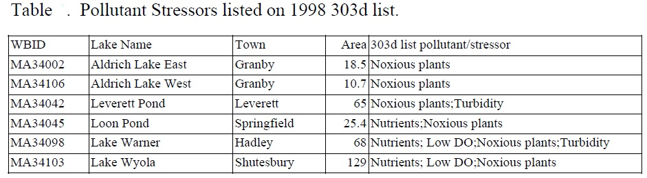
Unfortunately, no detailed study of the nutrient sources within the watersheds has been conducted to date. Thus, nutrient sources were estimated based on land use modeling within the DEP’s NPSLAKE model. The NPSLAKE model of Mattson and Isaac (1999) was designed to estimate watershed loading rates of phosphorus to lakes. The phosphorus loading estimates from the model are used with estimates of water runoff and these are used as inputs into a water quality model of Reckhow (1979). A brief description of the NPSLAKE model and data inputs is given here. MassGIS digital maps of land use within the watershed were used to calculate areas of landuse within three major types: Forest, rural and urban landuse. This model takes the area in hectares of land use within each of three categories and applies an export coefficient to each to predict the annual external loading of phosphorus to the lake from the watershed. Because much of the landuse data is based on old (1985) aerial photographs, the current landuses within the watershed may be different today. This can be important in the development of the TMDL because different landuses can result in different phosphorus loadings to the waterbody in question. For many rural areas, landuse changes often result in conversion of open or agricultural lands to low density housing, in which case, the export coefficients of the NPSLAKE model are the same and no change in loading is predicted to occur. However, in cases where development changes forests to residential areas or rural landuses to urban landuses, phosphorus loadings are predicted to increase. In some cases, loadings are predicted to decrease if additional agricultural land is abandoned and forest regrowth occurs. To account for this uncertainty in landuse changes, a conservative target is chosen. In addition, the MassGIS landuse maps are scheduled to be updated with current aerial photos and the TMDL can be modified as additional information is obtained.
Other phosphorus sources, such as septic system inputs of phosphorus, are estimated from an export coefficient multiplied by the number of homes within 100 meters of the lake. Point sources are estimated manually based on discharge information and site-specific information for uptake and storage. Other sources such as atmospheric deposition to lakes was determined to be small and not significant in the NPSLAKE model, perhaps because lakes tend to be sinks rather than sources of phosphorus (Mattson and Isaac, 1999). For similar reasons wetlands were also not considered to be significant sources of phosphorus following (Mattson and Isaac, 1999). Other, non-landuse sources of phosphorus such as inputs from waterfowl were not included, but can be added as additional information becomes available. If large numbers of waterfowl are using the lake the total phosphorus budget may be an underestimate, and control measures should be considered.
Internal sources (recycling) of phosphorus is not included because it is not considered as a net external load to the lake, but rather a seasonal recycling of phosphorus already present in the lake. In cases where this internal source is large it may result in surface concentrations higher than predicted from landuse loading models and may contribute to water quality violations during the critical summer period. As additional monitoring data become available, these lakes will be assessed for internal contributions and possibly control of these sources by alum or other means. The major sources according to the land use analysis are shown for the lake in the following table (from “Total Maximum Daily Loads of Phosphorus for Selected Connecticut Basin Lakes”, 2001).
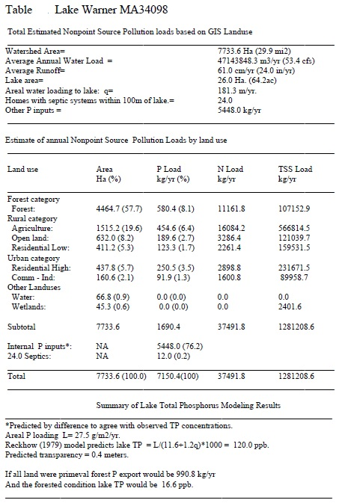
The NPSLAKE model assumes land uses are accurately represented by the MassGIS digital maps and that land use has not changed appreciably since the maps were compiled in 1985. The predicted loading is based on the equation:
P Loading (kg/yr)= 0.5* septics + 0.13* forest ha + 0.3* rural ha + 14* (urban ha)0.5
The coefficients of the model are based on a combination of values estimated with the aid of multiple regression on a Massachusetts data set and of typical values reported in previous diagnostic/feasibility studies in Massachusetts.
All coefficients fall within the range of values reported in other studies. Further details on the methods, assumptions, calibration and validation of the NPSLAKE model can be found in Mattson and Isaac (1999). The overall standard error of the model is approximately 172 kg/yr. If not data is available for internal loading a rough estimate of the magnitude of this sources can be estimated from the Reckhow model by substitution of the in-lake concentration for TP. The difference in predicted loadings from this approach and the landuse approach is the best estimate of internal loading.
The NPSLAKE model also generates predictions of estimated yearly average water runoff to the lake based on total watershed area and runoff maps of Massachusetts (Mattson and Isaac, 1999). Other estimates of nitrogen and total suspended solid (TSS) loading rates are estimates based on Reckhow et al.(1980), and are provided here for informational and comparison purposes only.
Because of the general nature of the landuse loading approach, natural background is included in land use based export coefficients. Natural background can be estimated based on the forest export coefficient of 0.13 kg/ha/yr multiplied by the hectares of the watershed assuming the watershed to be entirely forested. Without site specific information regarding soil phosphorus and natural erosion rates the accuracy of this estimate would be uncertain and would add little value to the analysis.
Mattson, M.D. and R.A. Isaac. 1999. Calibration of Phosphorus Export coefficients for Total Maximum Daily Loads of Massachusetts Lakes. Lake and Reservoir Man. 15(3):209-219.
Reckhow, K.H. 1979. Uncertainty Analysis Applied to Vollenweider’s Phosphorus Loading Criteria. J. Water Poll. Control Fed. 51(8):2123-2128.
Reckhow, K.H., M.N. Beaulac, J.T. Simpson. 1980. Modeling Phosphorus Loading and Lake Response Under Uncertainty: A Manual and Compilation of Export Coefficients. U.S.E.P.A. Washington DC. EPA 440/5-80-011.
Snow, P.D., and F.A. DiGiano. 1976. Mathematical Modeling of Phosphorus Exchange Between Sediments and Overlying Water in Shallow Eutrophic Lakes. Sept. 1976 Report No. Env. E. 54-76-3, Envir. Eng. Dept. Civil Eng. Umass, Amherst, MA.

Connecticut River Watershed 2003 Water Quality Assessment Report (MA34042 - Leverett Pond)
AQUATIC LIFE
Biology
Two non-native species (Myriophyllum spicatum and Najas minor) were documented in Leverett Pond in 1998 (MassDEP 1998).
The Aquatic Life Use for this segment is assessed as impaired based on the presence of non-native species.
CONNECTICUT RIVER WATERSHED – LAKE SEGMENTS ASSESSED
Currently there is uncertainty associated with the accurate reporting of freshwater beach closure information to MA DPH, which is required as part of the Beaches Bill. Therefore, no Primary Contact Recreational Use assessments (either support or impairment) decisions are being made using Beaches Bill data for these waterbodies. Bathing beaches located in this watershed are listed in their respective lake segments.
The City of Springfield received a grant to monitor the water quality of the lakes and ponds within the city limits, and monitoring was conducted during 2001 and 2002 (Godfrey 2007). A QAPP was submitted and approved in 2003 to document data collection methods. However, no additional data collection took place after 2002 under the direction of that QAPP (Connors 2007), thus these data are not used to make assessment decisions. Clear violations of criteria noted in these data have been described in the appropriate segment and may result in an Alert Status for the appropriate use.
Report Recommendations:
Continue to monitor for the presence of invasive non-native aquatic vegetation and determine the extent of the infestation. Prevent spreading of invasive aquatic plants. Once the extent of the problem is determined and control practices are exercised, vigilant monitoring needs to be practiced to guard against infestations in unaffected areas, including downstream from the site, and to ensure that managed areas stay in check. A key portion of the prevention program should be posting of boat access points with signs to educate and alert lake-users to the problem and their responsibility to prevent spreading these species.
Conduct water quality monitoring to evaluate designated uses.

Total Maximum Daily Loads of Phosphorus for Selected Connecticut Basin Lakes
(MA34042 - Leverett Pond)
Leverett Pond in Leverett is a large pond of approximately 65 acres. The watershed is 60 percent forested, 23 percent water and wetlands, 15 percent rural and the remaining 2 percent consists of high-density residential land use. Populations in Leverett ranged between 1,471 and 1,785 from 1980 to the 1990 census. Miser predictions on growth are 2,083 for the year 2000 and 2,289 for the year 2010 with an estimated 20-year growth rate of about 28 percent. Secchi depth was recorded at 3.8 m in 1978, however, Leverett Pond was assessed by DEP in the summer of 1994 and the assessment comments reported: "Very dense growths of aquatic macrophytes cover the entire littoral zone. The non-native macrophyte Myriophyllum spicatum has been detected, via citizen monitoring and confirmed by DWPC limnologists, in the northwest portion of the lake and along the eastern shore. Populations have been expanding and threaten the entire lake. Citizen monitoring data during summer 1993 indicated three months of Secchi disk transparency values below the safety criteria (<1.2 m). "
The pollutant stressors reported on the 1998 303d list which are related to this phosphorus TMDL are listed in the table below.
Unfortunately, no detailed study of the nutrient sources within the watersheds has been conducted to date. Thus, nutrient sources were estimated based on land use modeling within the DEP’s NPSLAKE model. The NPSLAKE model of Mattson and Isaac (1999) was designed to estimate watershed loading rates of phosphorus to lakes. The phosphorus loading estimates from the model are used with estimates of water runoff and these are used as inputs into a water quality model of Reckhow (1979). A brief description of the NPSLAKE model and data inputs is given here. MassGIS digital maps of land use within the watershed were used to calculate areas of landuse within three major types: Forest, rural and urban landuse. This model takes the area in hectares of land use within each of three categories and applies an export coefficient to each to predict the annual external loading of phosphorus to the lake from the watershed. Because much of the landuse data is based on old (1985) aerial photographs, the current landuses within the watershed may be different today. This can be important in the development of the TMDL because different landuses can result in different phosphorus loadings to the waterbody in question. For many rural areas, landuse changes often result in conversion of open or agricultural lands to low density housing, in which case, the export coefficients of the NPSLAKE model are the same and no change in loading is predicted to occur. However, in cases where development changes forests to residential areas or rural landuses to urban landuses, phosphorus loadings are predicted to increase. In some cases, loadings are predicted to decrease if additional agricultural land is abandoned and forest regrowth occurs. To account for this uncertainty in landuse changes, a conservative target is chosen. In addition, the MassGIS landuse maps are scheduled to be updated with current aerial photos and the TMDL can be modified as additional information is obtained.
Other phosphorus sources, such as septic system inputs of phosphorus, are estimated from an export coefficient multiplied by the number of homes within 100 meters of the lake. Point sources are estimated manually based on discharge information and site-specific information for uptake and storage. Other sources such as atmospheric deposition to lakes was determined to be small and not significant in the NPSLAKE model, perhaps because lakes tend to be sinks rather than sources of phosphorus (Mattson and Isaac, 1999). For similar reasons wetlands were also not considered to be significant sources of phosphorus following (Mattson and Isaac, 1999). Other, non-landuse sources of phosphorus such as inputs from waterfowl were not included but can be added as additional information becomes available. If large numbers of waterfowl are using the lake the total phosphorus budget may be an underestimate, and control measures should be considered.
Internal sources (recycling) of phosphorus is not included because it is not considered as a net external load to the lake, but rather a seasonal recycling of phosphorus already present in the lake. In cases where this internal source is large it may result in surface concentrations higher than predicted from landuse loading models and may contribute to water quality violations during the critical summer period. As additional monitoring data become available, these lakes will be assessed for internal contributions and possibly control of these sources by alum or other means. The major sources according to the land use analysis are shown for the lake in the following table (from “Total Maximum Daily Loads of Phosphorus for Selected Connecticut Basin Lakes”, 2001).
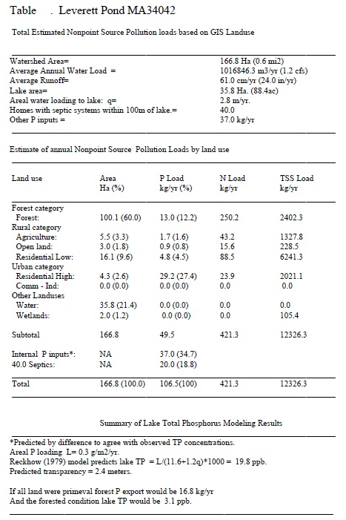
The NPSLAKE model assumes land uses are accurately represented by the MassGIS digital maps and that land use has not changed appreciably since the maps were compiled in 1985. The predicted loading is based on the equation:
P Loading (kg/yr)= 0.5* septics + 0.13* forest ha + 0.3* rural ha + 14* (urban ha)0.5
The coefficients of the model are based on a combination of values estimated with the aid of multiple regression on a Massachusetts data set and of typical values reported in previous diagnostic/feasibility studies in Massachusetts.
All coefficients fall within the range of values reported in other studies. Further details on the methods, assumptions, calibration and validation of the NPSLAKE model can be found in Mattson and Isaac (1999). The overall standard error of the model is approximately 172 kg/yr. If not data is available for internal loading a rough estimate of the magnitude of this sources can be estimated from the Reckhow model by substitution of the in-lake concentration for TP. The difference in predicted loadings from this approach and the landuse approach is the best estimate of internal loading.
The NPSLAKE model also generates predictions of estimated yearly average water runoff to the lake based on total watershed area and runoff maps of Massachusetts (Mattson and Isaac, 1999). Other estimates of nitrogen and total suspended solid (TSS) loading rates are estimates based on Reckhow et al.(1980), and are provided here for informational and comparison purposes only.
Because of the general nature of the landuse loading approach, natural background is included in land use based export coefficients. Natural background can be estimated based on the forest export coefficient of 0.13 kg/ha/yr multiplied by the hectares of the watershed assuming the watershed to be entirely forested. Without site specific information regarding soil phosphorus and natural erosion rates the accuracy of this estimate would be uncertain and would add little value to the analysis.
In the case of Leverett Pond, the NPSLAKE model predictions of in-lake total phosphorus based on landuse do not agree well with in-lake total phosphorus concentrations observed in 1993 (although they do agree with conditions in 1978). As noted above, volunteer measurements of Secchi disk depths were less than 1.2 meters in 1993 and total phosphorus concentrations were 20 ppb, but the model predicts transparency to be 3.7 meters based on predicted total phosphorus concentrations of 12.9 ppb. Thus, there is probably an additional source of phosphorus to the pond and the most likely source is internal phosphorus from the sediments. This source was estimated by difference so that the new model predictions agree with the observed concentration. Further study on phosphorus sources to this pond is suggested.
Mattson, M.D. and R.A. Isaac. 1999. Calibration of Phosphorus Export coefficients for Total Maximum Daily Loads of Massachusetts Lakes. Lake and Reservoir Man. 15(3):209-219.
Reckhow, K.H. 1979. Uncertainty Analysis Applied to Vollenweider’s Phosphorus Loading Criteria. J. Water Poll. Control Fed. 51(8):2123-2128.
Reckhow, K.H., M.N. Beaulac, J.T. Simpson. 1980. Modeling Phosphorus Loading and Lake Response Under Uncertainty: A Manual and Compilation of Export Coefficients. U.S.E.P.A. Washington DC. EPA 440/5-80-011.

Connecticut River Watershed 2008 DWM Water Quality Monitoring Data (MA34-25 - Mill River-Hadley)
Water Quality Monitoring Data
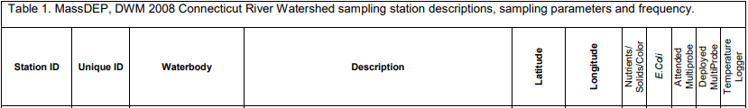

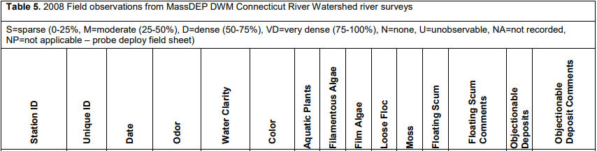
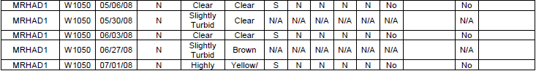
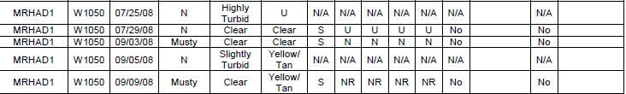

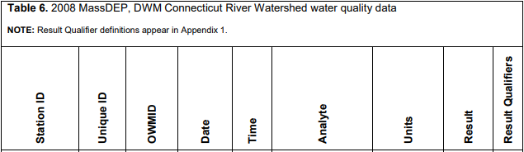
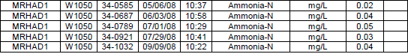
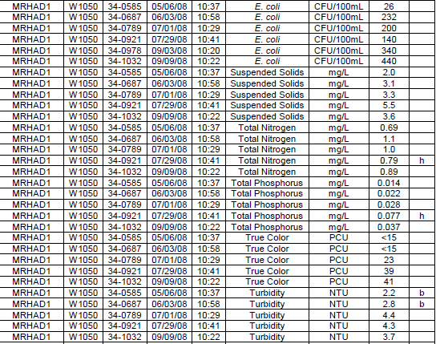

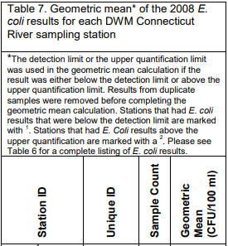

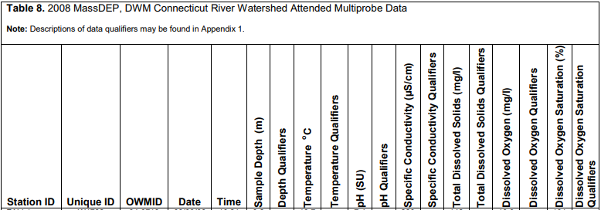
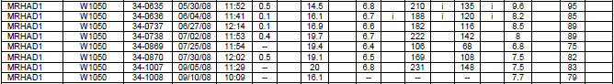
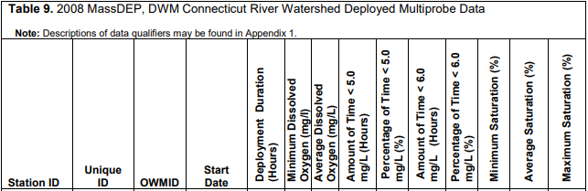

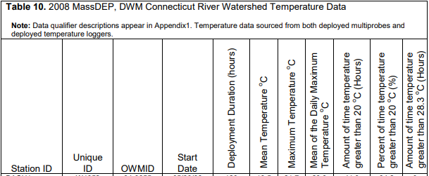

Water Quality Impairments
Known water quality impairments, as documented in the MassDEP 2016 Massachusetts Integrated List of Waters, are listed below in Table A-3 for waterbodies in the Mill River watershed area. Impairment categories from the Integrated List are included in Table A-2.
Table A-2: 2016 MA Integrated List of Waters Categories
Integrated List Category | Description
1 | Unimpaired and not threatened for all designated uses.
2 | Unimpaired for some uses and not assessed for others.
3 | Insufficient information to make assessments for any uses.
4 | Impaired or threatened for one or more uses, but not requiring calculation of a Total Maximum Daily Load (TMDL), including:  4a: TMDL is completed  4b: Impairment controlled by alternative pollution control requirements  4c: Impairment not caused by a pollutant - TMDL not required
5 | Impaired or threatened for one or more uses and requiring preparation of a TMDL.

Table A-3: Water Quality Impairments
Assessment  Unit ID | Waterbody | Integrated  List  Category | Designated Use | Impairment Cause | Impairment Source
MA34042 | Leverett Pond | 4A | Fish, other Aquatic Life and Wildlife | Eurasian Water Milfoil, Myriophyllum spicatum | Introduction of Non-native Organisms (Accidental or Intentional)
MA34042 | Leverett Pond | 4A | Fish, other Aquatic Life and Wildlife | Non-Native Aquatic Plants | Introduction of Non-native Organisms (Accidental or Intentional)
MA34042 | Leverett Pond | 4A | Primary Contact Recreation | Eurasian Water Milfoil, Myriophyllum spicatum | Introduction of Non-native Organisms (Accidental or Intentional)
MA34042 | Leverett Pond | 4A | Primary Contact Recreation | Non-Native Aquatic Plants | Introduction of Non-native Organisms (Accidental or Intentional)
MA34042 | Leverett Pond | 4A | Primary Contact Recreation | Nutrient/Eutrophication Biological Indicators | Internal Nutrient Recycling
MA34042 | Leverett Pond | 4A | Primary Contact Recreation | Nutrient/Eutrophication Biological Indicators | On-site Treatment Systems (Septic Systems and Similar Decentralized Systems)
MA34042 | Leverett Pond | 4A | Primary Contact Recreation | Nutrient/Eutrophication Biological Indicators | Rural (Residential Areas)
MA34042 | Leverett Pond | 4A | Secondary Contact Recreation | Eurasian Water Milfoil, Myriophyllum spicatum | Introduction of Non-native Organisms (Accidental or Intentional)
MA34042 | Leverett Pond | 4A | Secondary Contact Recreation | Non-Native Aquatic Plants | Introduction of Non-native Organisms (Accidental or Intentional)
MA34042 | Leverett Pond | 4A | Secondary Contact Recreation | Nutrient/Eutrophication Biological Indicators | Rural (Residential Areas)
MA34042 | Leverett Pond | 4A | Secondary Contact Recreation | Nutrient/Eutrophication Biological Indicators | Internal Nutrient Recycling
MA34042 | Leverett Pond | 4A | Secondary Contact Recreation | Nutrient/Eutrophication Biological Indicators | On-site Treatment Systems (Septic Systems and Similar Decentralized Systems)
MA34042 | Leverett Pond | 4A | Aesthetic | Eurasian Water Milfoil, Myriophyllum spicatum | Introduction of Non-native Organisms (Accidental or Intentional)
MA34042 | Leverett Pond | 4A | Aesthetic | Non-Native Aquatic Plants | Introduction of Non-native Organisms (Accidental or Intentional)
MA34042 | Leverett Pond | 4A | Aesthetic | Nutrient/Eutrophication Biological Indicators | On-site Treatment Systems (Septic Systems and Similar Decentralized Systems)
MA34042 | Leverett Pond | 4A | Aesthetic | Nutrient/Eutrophication Biological Indicators | Rural (Residential Areas)
MA34042 | Leverett Pond | 4A | Aesthetic | Nutrient/Eutrophication Biological Indicators | Internal Nutrient Recycling
MA34098 | Lake Warner | 4A | Fish, other Aquatic Life and Wildlife | Algae | Source Unknown
MA34098 | Lake Warner | 4A | Fish, other Aquatic Life and Wildlife | Dissolved Oxygen | Source Unknown
MA34098 | Lake Warner | 4A | Fish, other Aquatic Life and Wildlife | Non-Native Aquatic Plants | Introduction of Non-native Organisms (Accidental or Intentional)
MA34098 | Lake Warner | 4A | Fish, other Aquatic Life and Wildlife | Phosphorus, Total | Source Unknown
MA34098 | Lake Warner | 4A | Fish, other Aquatic Life and Wildlife | Turbidity | Source Unknown
MA34-25 | Mill River | 5 | Primary Contact Recreation | Escherichia Coli (E. coli) | Unspecified Urban Stormwater
MA34-25 | Mill River | 5 | Primary Contact Recreation | Escherichia Coli (E. coli) | Agriculture
MA34-25 | Mill River | 5 | Primary Contact Recreation | Escherichia Coli (E. coli) | Source Unknown
MA34098 | Lake Warner | 4A | Fish, other Aquatic Life and Wildlife | Non-Native Aquatic Plants | Introduction of Non-native Organisms (Accidental or Intentional)

Additional Water Quality Data
E. coli data obtained from approximately 1/4-mile upstream of where the Mill River enters Lake Warner (collected by the “Friends of Lake Warner and the Mill River”) was collected in 2017, 2018, and 2019 and had a geometric mean of 392, 772 and 480 colonies/ 100 ml, respectively (Johnson, 2019), which is substantially above the Massachusetts Surface Water Quality Standard of 126 colonies/ 100 ml (MassDEP 2003). TP data was also collected at this location in 2003, 2015, 2018 and 2019 and had an average of 71 ug/l of TP (Johnson, 2019), which is above the water quality criteria of 50 ug/L (USEPA 1986).

Water Quality Goals
Water quality goals may be established for a variety of purposes, including the following:
- For waterbodies with known impairments, a Total Maximum Daily Load (TMDL) is established by MassDEP and the United States Environmental Protection Agency (USEPA) as the maximum amount of the target pollutant that the waterbody can receive and still safely meet water quality standards. If the waterbody has a TMDL for total phosphorus (TP) or total nitrogen (TN), or total suspended solids (TSS), that information is provided below and included as a water quality goal.
- For waterbodies without a TMDL for total phosphorus (TP), a default water quality goal for TP is based on target concentrations established in the Quality Criteria for Water (USEPA, 1986) (also known as the “Gold Book”). The Gold Book states that TP should not exceed 50 ug/L in any stream at the point where it enters any lake or reservoir, nor 25 ug/L within a lake or reservoir. For the purposes of developing WBPs, MassDEP has adopted 50 ug/L as the TP target for all streams at their downstream discharge point, regardless of which type of water body the stream discharges to.
- Massachusetts Surface Water Quality Standards (314 CMR 4.00, 2013) prescribe the minimum water quality criteria required to sustain a waterbody’s designated uses. Table A-4 lists the Class for each Assessment Unit ID within the Mill River watershed. The water quality goal(s) for bacteria are based on the Massachusetts Surface Water Quality Standards.

Table A-4: Surface Water Quality Classification by Assessment Unit ID
Assessment  Unit ID | Waterbody | Class
MA34-25 | Mill River | B
MA34-34 | Cushman Brook | B
MA34098 | Lake Warner | B
MA34042 | Leverett Pond | B

- Other water quality goals set by the community (e.g., protection of high-quality waters, in-lake phosphorus concentration goal to reduce recurrence of cyanobacteria blooms, etc.).
Refer to Table A-5 for a list of water quality goals. Element C of this WBP includes proposed BMPs to address these impairments, including BMPs that provided increases in infiltration. Infiltration is a commonly used method to reduce phosphorus and bacteria loads in stormwater runoff and it can also help with peak runoff rate attenuation, reduced thermal impacts to receiving waters, and enhanced base flow to receiving waters (USEPA, 2014).

Table A-5: Water Quality Goals

Pollutant | Waterbody Name (Assessment Unit ID(s)) | Goal | Source
Total Phosphorus (TP) | Mill River (MA34-25) | Total phosphorus should not exceed:  --50 ug/L in any stream  --25 ug/L within any lake or reservoir | Quality Criteria for Water (USEPA, 1986)
Additional TMDL Criteria | Lake Warner (MA34098) | Total phosphorus should not exceed:  30 ug/L (30 ppb) | Total Maximum Daily Loads of Phosphorus for Selected Connecticut Basin Lakes
 | Leverett Pond (MA34042) | Total phosphorus should not exceed:  15 ug/L (15 ppb) | Total Maximum Daily Loads of Phosphorus for Selected Connecticut Basin Lakes
E. coli | All Assessment Units within the watershed | Class B Standards  • Public Bathing Beaches: For E. coli, geometric mean of 5 most recent samples shall not exceed 126 colonies/ 100 ml and no single sample during the bathing season shall exceed 235 colonies/100 ml. For enterococci, geometric mean of 5 most recent samples shall not exceed 33 colonies/100 ml and no single sample during bathing season shall exceed 61 colonies/100 ml;  • Other Waters and Non-bathing Season at Bathing Beaches: For E. coli, geometric mean of samples from most recent 6 months shall not exceed 126 colonies/100 ml (typically based on min. 5 samples) and no single sample shall exceed 235 colonies/100 ml. For enterococci, geometric mean of samples from most recent 6 months shall not exceed 33 colonies/100 ml, and no single sample shall exceed 61 colonies/100 ml. | Massachusetts Surface Water Quality Standards (314 CMR 4.00, 2013)

Land Use Information
Land use information and impervious cover is presented by the below tables and figures. Land use source data is from 2005 and was obtained from MassGIS (2009b).

Watershed Land Uses
As summarized by Table A-6, land use in the Mill River watershed is mostly forested (approximately 66 percent); approximately 14 percent of the watershed is agricultural; approximately 5 percent of the watershed is open land or water; approximately 5 percent of the watershed is commercial or industrial; approximately 9 percent is residential; and approximately 1 percent is devoted to highways.
Table A-6: Subwatershed Land Uses
Land Use | Area (acres) | % of Watershed
Forest | 12,835.70 | 65.9
Agriculture | 2,698.37 | 13.9
Low Density Residential | 967.28 | 5
Commercial | 852.03 | 4.4
Open Land | 796.63 | 4.1
Medium Density Residential | 448.81 | 2.3
High Density Residential | 353.85 | 1.8
Water | 277.51 | 1.4
Industrial | 131.71 | 0.7
Highway | 101.88 | 0.5

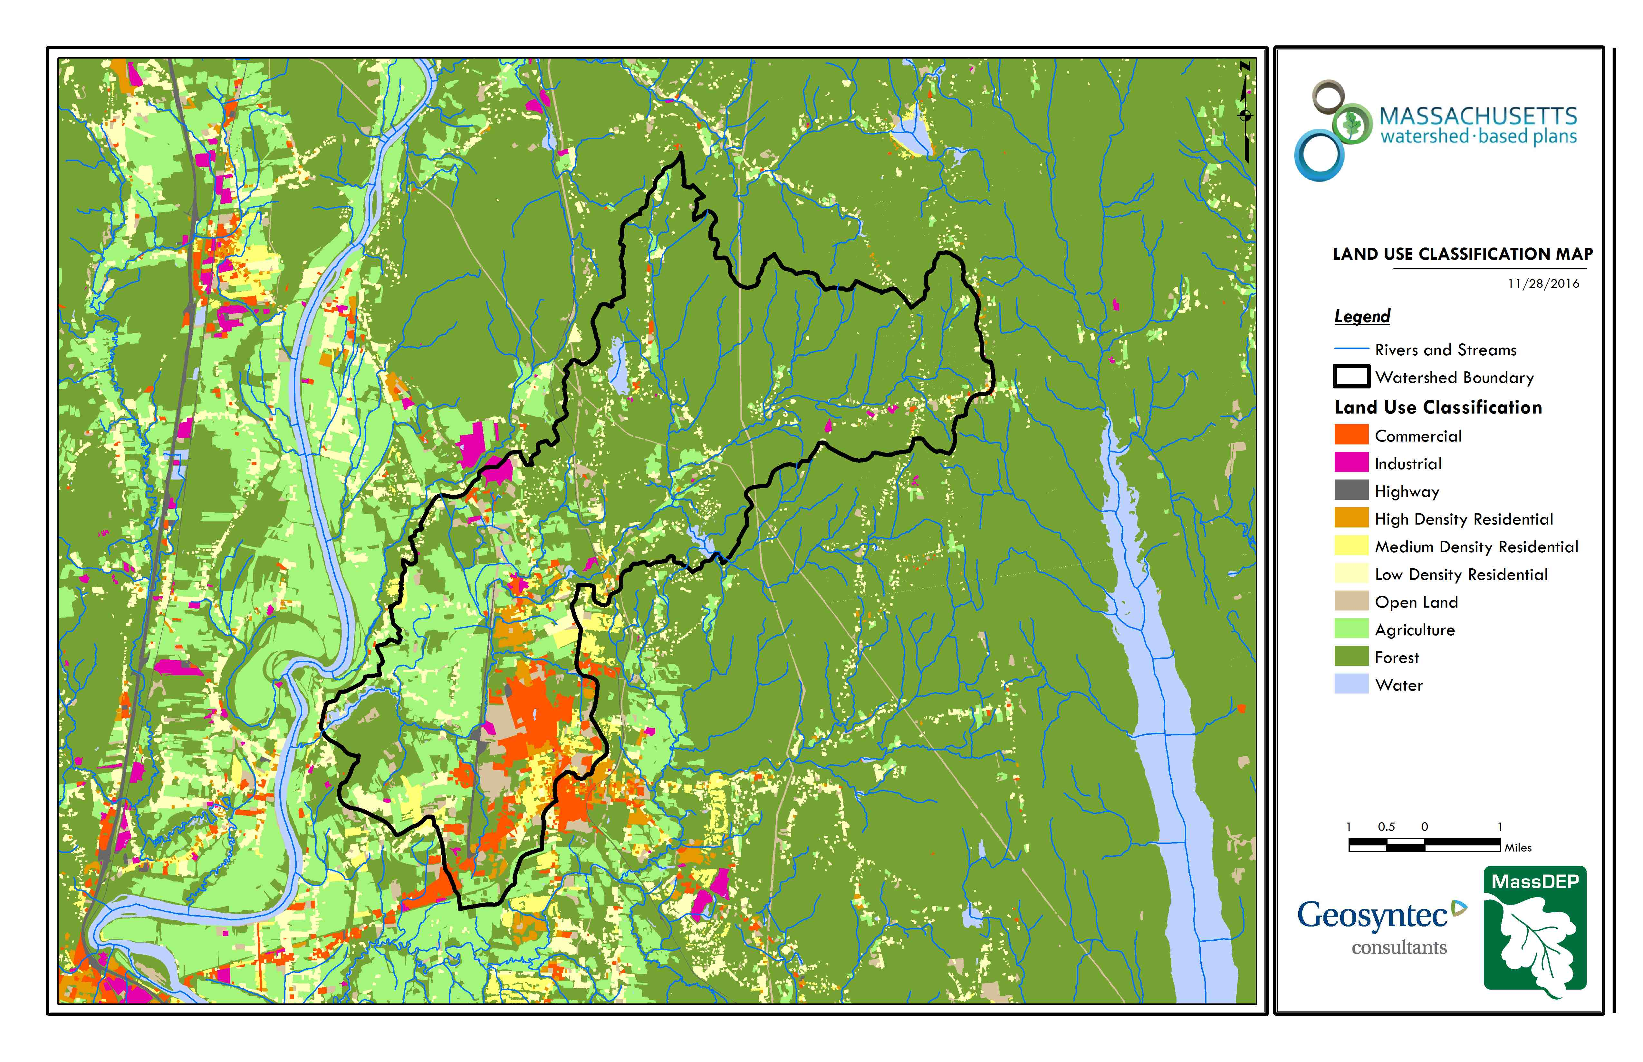
Leverett Pond
Puffers Pond
Mill River
Lake Warner
Figure A-2: Subwatershed Land Use Map
(MassGIS, 2007; MassGIS, 2009b; MassGIS, 1999; MassGIS, 2001; USGS, 2016)

Watershed Impervious Cover
There is a strong link between impervious land cover and stream water quality. Impervious cover includes land surfaces that prevent the infiltration of water into the ground, such as paved roads and parking lots, roofs, basketball courts, etc. Impervious area within the watershed of the Mill River is mostly concentrated in the Amherst town center and the University of Massachusetts, as illustrated in Figure A-8 below.
Impervious areas that are directly connected (DCIA) to receiving waters (via storm sewers, gutters, or other impervious drainage pathways) produce higher runoff volumes and transport stormwater pollutants with greater efficiency than disconnected impervious cover areas which are surrounded by vegetated, pervious land. Runoff volumes from disconnected impervious cover areas are reduced as stormwater infiltrates when it flows across adjacent pervious surfaces.
An estimate of DCIA for the subwatershed area was calculated based on the Sutherland equations. USEPA provides guidance (USEPA, 2010) on the use of the Sutherland equations to predict relative levels of connection and disconnection based on the type of stormwater infrastructure within the total impervious area (TIA) of a watershed. Within the subwatershed, the total area of each land use was summed and used to calculate the percent TIA (Table A-7).
Table A-7: TIA and DCIA values for the Watershed
 | Estimated TIA (%) | Estimated DCIA (%)
Mill River Watershed | 7.9 | 6.4

The relationship between TIA and water quality can generally be categorized as listed by Table A-8 (Schueler et al. 2009). The TIA value for the watershed range is 7.9%; therefore, the river and surrounding tributaries can be expected to show good to excellent water quality. It is likely there is a gradient of higher water quality in the upstream forested parts of the watershed while more downstream developed areas have more water quality stress.

Table A-8: Relationship between Total Impervious Area (TIA) and water quality (Schueler et al. 2009)
% Watershed  Impervious Cover | Stream Water Quality
0-10% | Typically high quality, and typified by stable channels, excellent habitat structure, good to excellent water quality, and diverse communities of both fish and aquatic insects.
11-25% | These streams show clear signs of degradation. Elevated storm flows begin to alter stream geometry, with evident erosion and channel widening. Streams banks become unstable, and physical stream habitat is degraded. Stream water quality shifts into the fair/good category during both storms and dry weather periods. Stream biodiversity declines to fair levels, with most sensitive fish and aquatic insects disappearing from the stream.
26-60% | These streams typically no longer support a diverse stream community. The stream channel becomes highly unstable, and many stream reaches experience severe widening, downcutting, and streambank erosion. Pool and riffle structure needed to sustain fish is diminished or eliminated and the substrate can no longer provide habitat for aquatic insects, or spawning areas for fish. Biological quality is typically poor, dominated by pollution tolerant insects and fish. Water quality is consistently rated as fair to poor, and water recreation is often no longer possible due to the presence of high bacteria levels.
>60% | These streams are typical of “urban drainage”, with most ecological functions greatly impaired or absent, and the stream channel primarily functioning as a conveyance for stormwater flows.

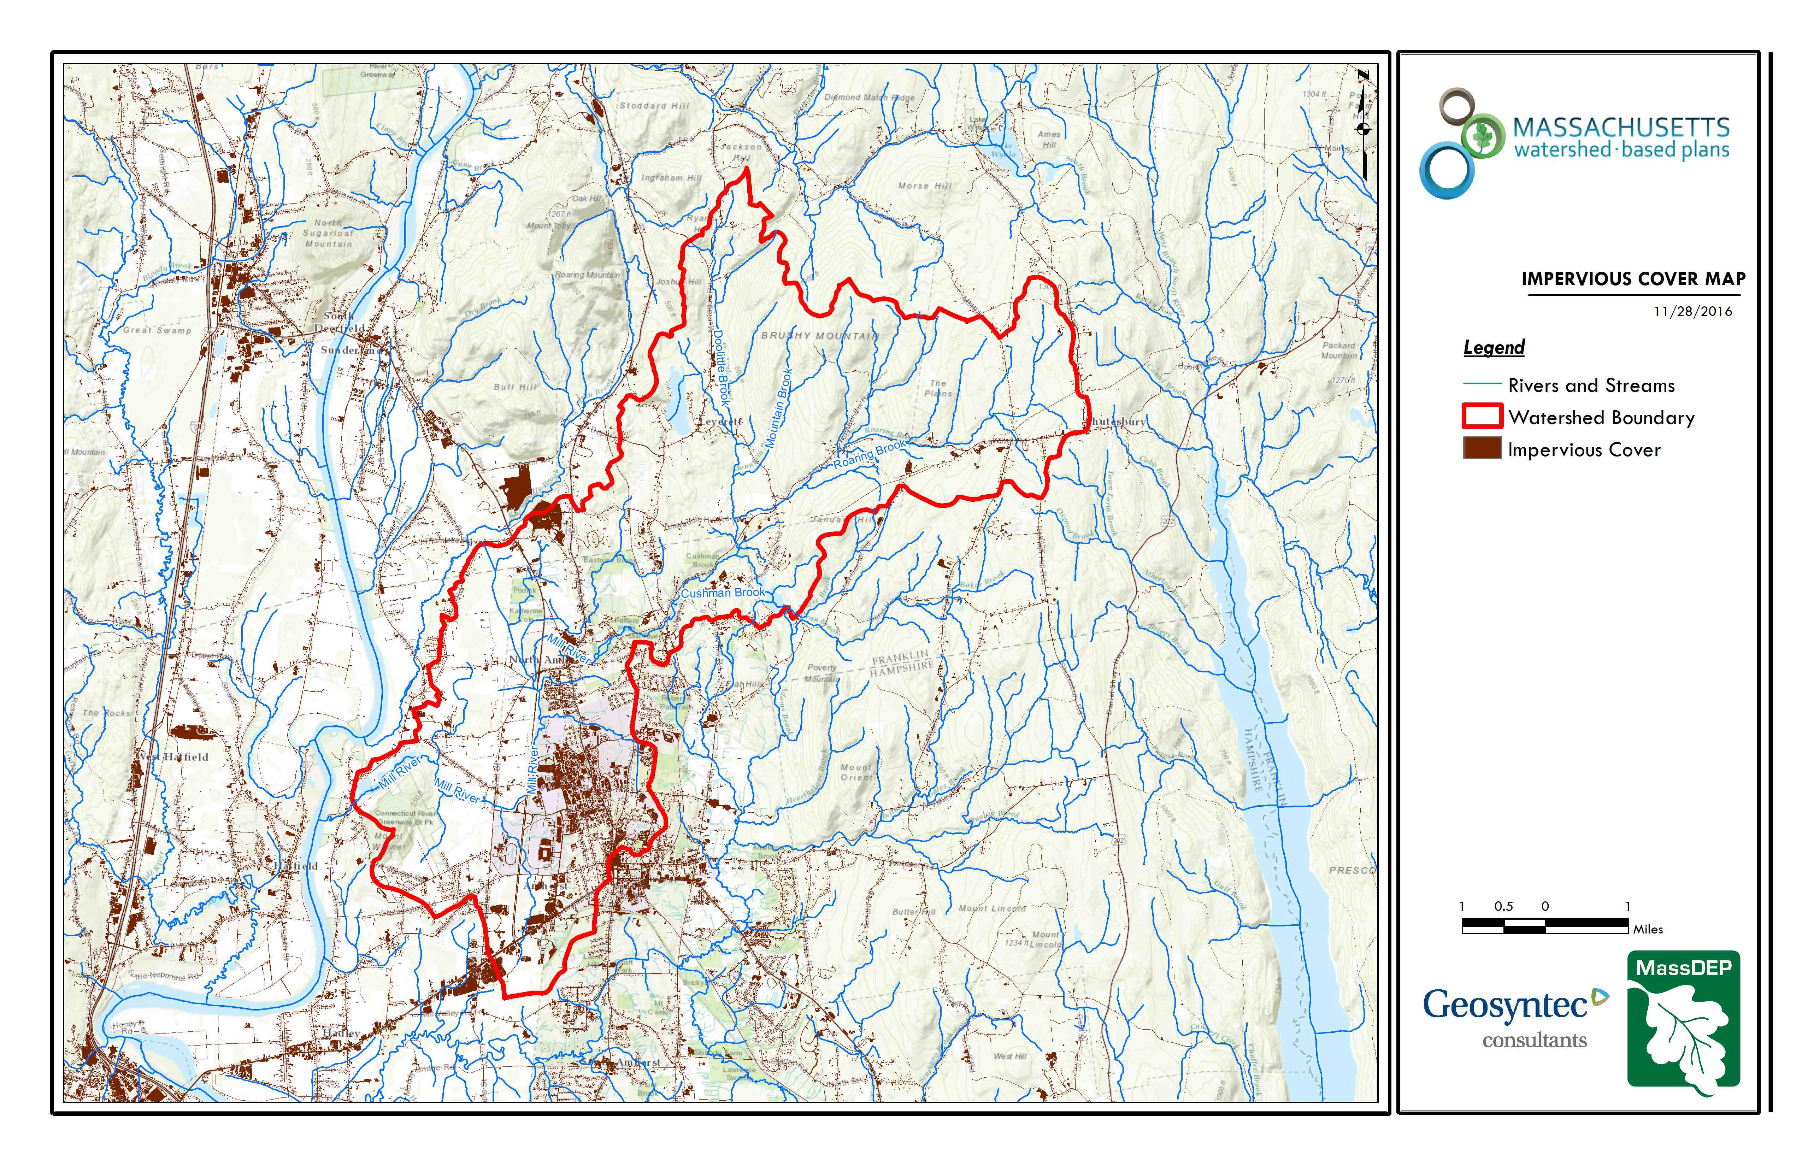
Figure A-3: Subwatershed Impervious Surface Map
(MassGIS, 2007; MassGIS 2009a; MassGIS, 1999; MassGIS, 2001; USGS, 2016)

Pollutant Loading
The land use data (MassGIS, 2009b) was intersected with impervious cover data (MassGIS, 2009a) and United States Department of Agriculture (USDA) Natural Resources Conservation Service (NRCS) soils data (USDA NRCS and MassGIS, 2012) to create a combined land use/land cover grid. The grid was used to sum the total area of each unique land use/land cover type.
The amount of DCIA was estimated using the Sutherland equations as described above and any reduction in impervious area due to disconnection (i.e., the area difference between TIA and DCIA) was assigned to the pervious D soil category for that land use to simulate that some infiltration will likely occur after runoff from disconnected impervious surfaces passes over pervious surfaces.
Pollutant loading for key nonpoint source pollutants in the subwatershed area was estimated by multiplying each land use/cover type area by its pollutant load export rate (PLER). The PLERs are an estimate of the annual total pollutant load exported via stormwater from a given unit area of a particular land cover type. The PLER values for TN, TP and TSS were obtained from USEPA (Voorhees, 2016b) (see documentation provided in Appendix A) as follows:
L_{n} = A_{n} * P_{n}
Where L_{n} = Loading of land use/cover type n (lb/yr); A_{n} = area of land use/cover type n (acres); P_{n} = pollutant load export rate of land use/cover type n (lb/acre/yr)

The estimated land use-based phosphorus to receiving waters within the subwatershed areas is 5,120 pounds per year, as presented by Table A-9. The largest contributor of the land use-based phosphorus and nitrogen load originates from areas designated as forested. Phosphorus and Nitrogen generated from forested areas is a result of natural process such as decomposition of leaf litter and other organic material and generally represent a “best case scenario” with regards to phosphorus and nitrogen loading, meaning that those portions of the watershed are unlikely to provide opportunities for nutrient load reductions through best management practices. The second largest contributors of the land use-based phosphorus and nitrogen load in the watershed are agricultural areas. Agricultural areas provide excellent opportunities for nutrient load reductions through agriculture best management practices.

Table A-9: Estimated Pollutant Loading for Key Nonpoint Source Pollutants
Land Use Type | Pollutant Loading¹
 | Total  Phosphorus (TP)  (lbs/yr) | Total  Nitrogen (TN)  (lbs/yr) | Total  Suspended Solids (TSS)  (tons/yr)
Forest | 1,752 | 8,903 | 319
Agriculture | 1,336 | 8,063 | 89
Commercial | 872 | 7,513 | 94
High Density Residential | 299 | 1,964 | 30
Open Land | 250 | 2,381 | 50
Low Density Residential | 237 | 2,317 | 32
Industrial | 166 | 1,425 | 18
Medium Density Residential | 138 | 1,175 | 17
Highway | 69 | 569 | 32
TOTAL | 5,120 | 34,309 | 680
¹These estimates do not consider loads from point sources or septic systems.

Element B: Determine Pollutant Load Reductions Needed to Achieve Water Quality Goals
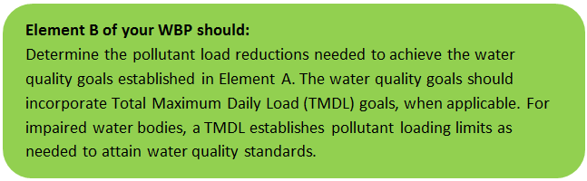

Estimated Pollutant Loads
Estimated pollutant loads for Total Phosphorus (TP) (5,120 lbs/yr), Total Nitrogen (TN) (34,309 lb/yr), and total suspended solids (TSS) (680 tons/yr) were previously presented in Element A of this WBP. E. coli loading has not been estimated for this WBP, because there are no known PLERs for E. coli. The TMDL for Lake Warner used the NPSLAKE model to estimate existing TP loads to Lake Warner. The TMDL estimated an existing TP load to Lake Warner of 7,150 kg/year (15,763 lb/year) (MassDEP, 2001); the difference between the TMDL value for TP loading and the value presented in Element A of this WBP is mostly attributed to differences in model assumptions (i.e., the NPSLAKE model also considers internal P sources and point sources to the lake whereas the methodology presented in Element A does not).

Water Quality Goals
There are many methodologies that can be used to set pollutant load reduction goals for a WBP. Goals can be based on water quality criteria, surface water standards, existing monitoring data, existing TMDL criteria, or other data.
As discussed in Element A, water quality goals for this WBP are focused on reducing E. coli and TP loading to the Mill River. TP water quality goals from this WBP are based on criteria from the Total Maximum Daily Loads of Phosphorus for Selected Connecticut Basin Lakes (MassDEP, 2001). The TMDL established an overall 75 percent load reduction goal of approximately 11,817 lb/year (5360 kg/year) for Lake Warner/Mill River watershed and provided waste load allocations (WLA) for TP based on specific land use areas (See Table B-1). The TMDL required the largest TP load reduction from internal P Sources while it required an approximately 41% reduction of TP from non-natural land use types. E. coli water quality goals of this WBP are based on MSWQS concentration standards and are difficult to predict based on estimated annual loading (see Table B-2).

Table B-1: Total Phosphorus Goals for Lake Warner/Mill River Watershed (Table adapted from "Total Maximum Daily Loads of Phosphorus for Selected Connecticut Basin Lakes " (MassDEP, 2001)

Source | Current TP Loading (lb/yr) | Target TP Load Allocation (lb/yr) | % Reduction Required
Forest | 1,279 | 1,279 | 0%
Agriculture | 1,014 | 595 | 41%
Open Land | 419 | 243 | 42%
Residential (Low den.) | 265 | 154 | 42%
Residential (High den.) | 551 | 331 | 40%
Comm. Indust. | 198 | 110 | 44%
Septic System | 22 | 22 | 0%
Internal P Sources | 12,015 | 1,213 | 90%
Total Inputs | 15,763 | 3,946 | 75%

Table B-2: Bacteria (E. coli) Goals for Mill River/Lake Warner Watershed
Pollutant | Existing Estimated Total Load | Water Quality Goal | Required Load Reduction
Bacteria | MSWQS for bacteria are concentration standards (e.g., colonies of fecal coliform bacteria per 100 ml), which are difficult to predict based on estimated annual loading. E. coli samples collected between April—November 2003 from the Mill River at Mill River Lane in Hadley (Station 25C) had a geometric mean of 148 colonies/100 ml. E. coli samples were collected from May—September 2008 at the same location and revealed a geometric mean of 171 colonies/ 100 ml (MassDEP 2008). E. coli data obtained from approximately 1/4-mile upstream of where the Mill River enters Lake Warner (collected by the “Friends of Lake Warner and the Mill River”) was collected in 2017, 2018, and 2019 and had a geometric mean of 392, 772 and 480 colonies/ 100 ml, respectively (Johnson, 2019), | Class B. Class B Standards  • Public Bathing Beaches: For E. coli, geometric mean of 5 most recent samples shall not exceed 126 colonies/ 100 ml and no single sample during the bathing season shall exceed 235 colonies/100 ml. For enterococci, geometric mean of 5 most recent samples shall not exceed 33 colonies/100 ml and no single sample during bathing season shall exceed 61 colonies/100 ml;  • Other Waters and Non-bathing Season at Bathing Beaches: For E. coli, geometric mean of samples from most recent 6 months shall not exceed 126 colonies/100 ml (typically based on min. 5 samples) and no single sample shall exceed 235 colonies/100 ml. For enterococci, geometric mean of samples from most recent 6 months shall not exceed 33 colonies/100 ml, and no single sample shall exceed 61 colonies/100 ml. | Concentration Based
The proposed projects described in this plan are expected to reduce both E. coli and TP loads to the Mill River, however, additional load reductions will be required to meet the water quality goals.
The following adaptive sequence is recommended to sequentially track and meet these load reduction goals:
- Given current water quality conditions and previous TMDL work, establish an interim goal to reduce land use-based phosphorus by 41% over the next 5 years (by 2024). Considering known pollutant loads for existing and proposed BMPs (please refer to the Introduction or Element C for more details on existing and proposed BMPs), it is anticipated that projects implemented in the past four years may reduce land use-based TP loading by 9,344 lb/year (Hashemi and Harper, 2018) and the proposed BMPs may reduced the land use-based TP loading by 665 lb/year (UMass, 2019), depending on influent loads to each BMP. It is noted that the anticipated load reduction numbers from the existing and proposed BMPs are greater than the existing agricultural estimated loads presented in Table B-1, which are from the TMDL (MassDEP, 2001). It is recommended that the estimated load reduction of the implemented agricultural BMPs be re-evaluated after a baseline water quality monitoring program is established and implemented (see step 3 below) to validate the accuracy of these estimates and confirm how much load is actually discharging to each BMP. In addition, the agricultural landuse-based TP loading estimate may be underestimating actual loading and therefore should be revised as more data are collected.
- Given current water quality conditions, establish an interim goal to reduce the geometric mean concentration of E. coli by 50% over the next 10 years (by 2029). Considering known pollutant loads for existing and proposed BMPs (please refer to the Introduction or Element C for more details on existing and proposed BMPs), it is anticipated that projects implemented in the past four years will reduce land use-based E. coli loading by 1.38 x10¹⁴ organisms/year and the proposed BMPs will reduced the land use-based E. coli loading by 2.48x10¹² organisms/year.
- Establish a baseline water quality monitoring program in accordance with Element I. Results from the monitoring program should advise if Element C management measures have been effective at addressing listed water quality impairments or water quality goals for other indicator parameters established by Element A.5 of this WBP (e.g., nitrogen, dissolved oxygen, chlorophyll-a). Results can further be used to periodically inform or adjust load reduction goals.
- Establish a long-term reduction goal to reduce land use-based phosphorus and E. coli over the next 15 years. Based on monitoring data, establish additional long-term reduction goal(s), if needed, to lead to delisting of all assessment units within the study watershed from the 303(d) list.

Element C: Describe management measures that will be implemented to achieve water quality goals

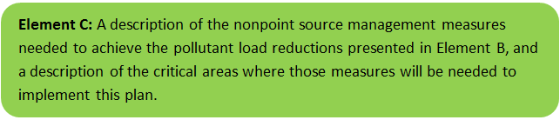Existing Management Measures
As indicated in the introduction of this WBP, the University of Massachusetts has implemented BMPs at five different agricultural sites over the past four years in the Mill River watershed. Resulting from the implementation of these BMPs, a combined TP reduction of 9,344 lb/year, TN reduction of 20,881 lb/year, TSS reduction of 3,060 tons/year and an average E. coli reduction of 1.38x10¹⁴ organisms per year was estimated (Hashemi and Harper, 2018).

Ongoing Management Measures
The University of Massachusetts, Amherst was awarded funding through the Fiscal Year 2020 Section 319 Nonpoint Source Pollution Grant Program to install the proposed structural BMPs at Full of Grace Farm in Hadley, which is within the Mill River Watershed. The proposed BMPs at Full of Grace Farm include:
- Installation of a solar powered static aerated composting system;
- Installation of three sacrifice lots with a total area of approximately 2,400 square feet;
- Installation of fencing to inhibit horses from directly accessing the Mill River and wetlands;
- Installation of gutters, french drain and underground pipes to direct clean water to the vegetated swale;
- Reparation of the existing eroded horse path; and
- Maintenance of the existing drainage swale to regain its intended purposed as conveyance stormwater treatment BMP.
The planning level cost estimates and pollutant load reduction estimates were based off information obtained from the “Implementation, Remediation, and Education of Selected Best Management Practices to Minimize the Environmental Impact of Two Equine Operations” Section 319 Nonpoint Source Pollution Grant Program application (UMass, 2019). It is anticipated that the BMPs at this location will result in a combined load reduction to the Mill River of 2,104 lbs N/year, 665 lbs P/year, and an average fecal coliform count of 2.48x10¹² organisms/year (UMass, 2019). A schematic of the proposed BMPs at Full of Grace Farm are presented in Figure C-1.
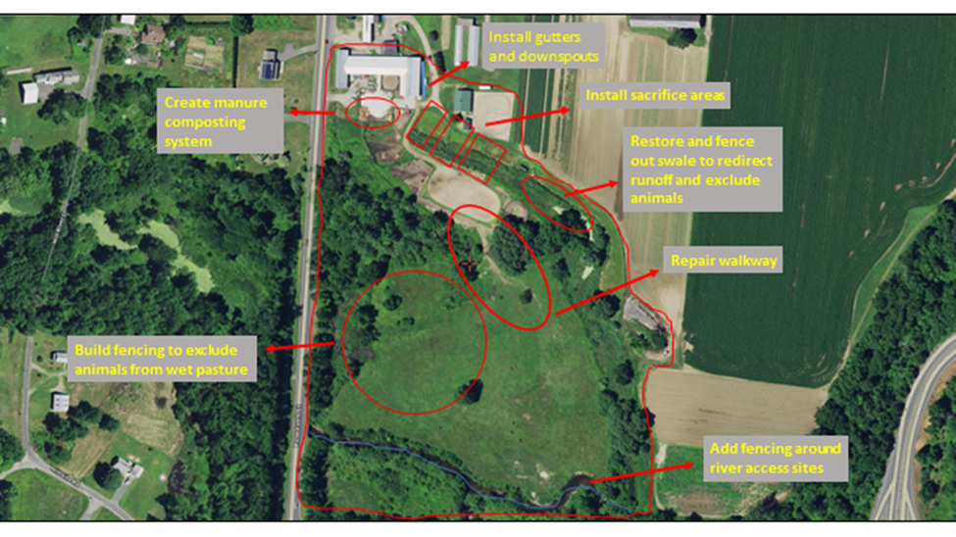
Figure C-1: Proposed BMPs at Full of Grace Farm (UMass, 2019)

Future Management Measures
As discussed by Element B, It is recommended that future planning initially focus on water quality goals related to E. coli and Phosphorus in the Mill River Watershed. It is recommended that management measures be recommended for future BMPs that emphasize reducing E. coli and TP loading to meet target water quality goals, as feasible. The following general sequence is recommended to identify and implement structural BMPs.
- Identify Potential Implementation Locations: Perform a desktop analysis using aerial imagery and GIS data to develop a preliminary list of potentially feasible implementation locations based on soil type (i.e., hydrologic soil groups A and B); available public open space (e.g., lawn area in front of a police station); potential redevelopment sites where additional public-private partnerships may be leveraged; and other factors such as proximity to receiving waters, known problem areas, or publicly owned right of ways or easements. Additional analysis can also be performed to fine-tune locations to maximize pollutant removals such as performing loading analysis on specifically delineated subwatersheds draining to single outfalls and selecting those subwatersheds with the highest loading rates per acre.
- Visit Potential Implementation Locations: Perform field reconnaissance, preferably during a period of active runoff-producing rainfall, to evaluate potential implementation locations, gauge feasibility, and identify potential BMP ideas. During field reconnaissance, assess identified locations for space constraints, potential accessibility issues, presence of mature vegetation that may cause conflicts (e.g., roots), potential utility conflicts, site-specific drainage patterns, and other factors that may cause issues during design, construction, or long-term maintenance.
- Develop BMP Concepts: Once potential BMP locations are conceptualized, use the BMP-selector tool on the watershed-based planning tool to help develop concepts. Concepts can vary widely. One method is to develop 1-page fact sheets for each concept that includes a site description, including definition of the problem, a description of the proposed BMPs, annotated site photographs with conceptual BMP design details, and a discussion of potential conflicts such as property ownership, O&M requirements, and permitting constraints. The fact sheet can also include information obtained from the BMP-selector tool including cost estimates, load reduction estimates, and sizing information (i.e., BMP footprint, drainage area, etc.).
- Rank BMP Concepts: Once BMP concepts are developed, perform a priority ranking based on site-specific factors to identify the implementation order. Ranking can include many factors including cost, expected pollutant load reductions, implementation complexity, potential outreach opportunities and visibility to public, accessibility, expected operation and maintenance effort, and others.
Prioritized BMP concepts should focus on reducing E. coli and TP loading to the Mill River as summarized by Element B.
Note that planned BMPs can also be non-structural (e.g., street sweeping, catch basin cleaning). It is recommended that these municipal programs be evaluated and potentially optimized. First, it is recommended that potential pollutant load removals from ongoing activities be calculated in accordance with Element HI. Next, it is recommended that ongoing activities be evaluated to see if potential improvements can be implemented to achieve higher pollutant load reductions such as increased frequency or improved technology.

Element D: Identify Technical and Financial Assistance Needed to Implement Plan
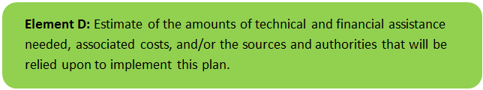

Current and Ongoing Management Measures
The funding needed to implement the proposed management measures presented in this watershed plan (proposed structural BMPs at Full of Grace Farm in Hadley) is based on estimates from the “Implementation, Remediation, and Education of Selected Best Management Practices to Minimize the Environmental Impact of Two Equine Operations” Section 319 Nonpoint Source Pollution Grant Program application (UMass, 2019). The total costs for structural and non-structural BMPs, operation and maintenance activities, information/education measures, and monitoring/evaluation activities is estimated at approximately $239,033, as detailed by Table D-1. Additionally, annual operation and maintenance costs were estimated, based on best professional judgment, to be two percent of the BMP supplies and contracts cost (i.e., approximately $1,400/year).
Table D-1: Summary of Proposed BMPs Costs (Full of Grace Farm, Hadley)
Expense Item | s.319 Amount | Non-Federal Match and Source | Total Amount
Salary and Wages
University staff (salary and 38.5% fringe) | $0 | $43,190 | $43,190
Technical Extension staff (salary and 2.03 fringe) | $38,858 | $0 | $38,858
Students Assistance (part time and 1.73 fringe) | $3,882 | $0 | $3,882
Supplies
Publications (posters, signage, worksheets) | $250 | $0 | $250
BMP supplies and contracts | $68,200 | $0 | $68,200
Travel | $750 | $0 | $750
Indirect Costs
26% indirect | $20,807 | $0 | $20,807
59.5% vs 26% waived indirect on Fed share | $0 | $52,508 | $52,508
Totals | $143,335 | $95,698 | $239,033

Future Management Measures
Funding for future BMP installations to further reduce loads within the watershed may be provided by a variety of sources, such as the Section 319 Nonpoint Source Pollution Grant Program, town capital funds, or other grant programs such as hazard mitigation funding. The University of Massachusetts has previously been successful with and will continue to pursue securing grant funding through various sources. Guidance is available to provide additional information on potential funding sources for nonpoint source pollution reduction efforts.

Element E: Public Information and Education
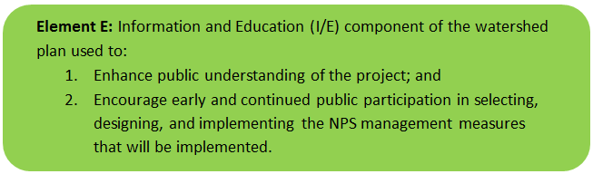

Step 1: Goals and Objectives
The goals and objectives for the watershed information and education program.
- Provide information about proposed stormwater improvements and their anticipated water quality benefits.
- Provide information to promote watershed stewardship.
Step 2: Target Audience
Target audiences that need to be reached to meet the goals and objectives identified above.
- All watershed residents.
- Businesses within the watershed.
- Farmers within the watershed (targeted through UMass Extension).
- Schools within the watershed, including the University of Massachusetts.
- Watershed organizations and other user groups, including the “Friends of Lake Warner and the Mill River” and the “Connecticut River Conservancy”.
- Horse owners and related groups (such as riding clubs).
Step 3: Outreach Products and Distribution
The outreach product(s) and distribution form(s) that will be used for each.
- Develop and post informational signs at proposed BMP locations (Full of Grace Farm BMP improvements).
- One annual field day at Full of Grace Farm, which will include an educational workshop for equine farm owners and its users on the BMPs.
- A minimum of five new and/or revised factsheets related to the various aspects of manure management, composting, protecting wetlands, sacrifice lots, pasture management, mud management, and controlling runoff will be generated and posted online (“Crops, Dairy, Livestock and Equine” UMass Extension website) and emailed to an equine list serve (800 members and counting).

Step 4: Evaluate Information/Education Program
Information and education efforts and how they will be evaluated.
- Track field day and workshop attendance at Full of Grace Farm.
- Tracking the number of fact sheet emails and the size of the list serve receiving the emails in addition to visitors to the UMass Extension webpage.

Elements F & G: Implementation Schedule and Measurable Milestones
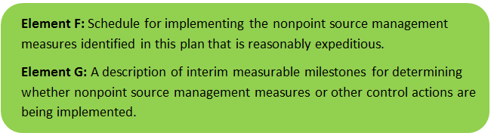

Table FG-1 provides a preliminary schedule for implementation of recommendations provided by this WBP. It is expected that the WBP will be re-evaluated and updated in 2023, or as needed, based on ongoing monitoring results and other ongoing efforts. New projects for further implementation of the watershed based plan will be identified through future data analysis and stakeholder engagement and will be included in updates to the implementation schedule.
Table FG-1: Implementation Schedule and Interim Measurable Milestones
Category | Action | Cost Estimate | Year(s)
Task 1: Establish Expert Guidance Team | Create an expert team consisting of a nutrient management specialist and a watershed specialist from UMass, representatives from NRCS and Hampden Hampshire Conservation Districts, along with manager and owner of Full of Grace Farm. | 5,000 | 2020
Task 2: Assessment, Installation, and Implementation of Best Management Practices on Moonlit Farm | Assess the needs of the individual sites to determine appropriate best management practices to reduce current existing non-point source pollution. Install and implement selected best management practices.  BMPs at FULL OF GRACE FARM:  - Installation of a solar powered static aerated composting system;  - Installation of three sacrifice lots with a total area of approximately 2,400 square feet;  - Installation of fencing to inhibit horses from directly accessing the Mill River and wetlands;  - Installation of gutters, french drain and underground pipes to direct clean water to the vegetated swale;  - Reparation of the existing eroded horse path; and  - Maintenance of the existing drainage swale to regain its intended purposed as conveyance stormwater treatment BMP. | $184,033 | 2020 -- 2021
Task 3 Educational Workshops, Meetings, Tours for Equine Industry and Community Horse Owners | Annual educational workshops on agricultural stormwater BMPs will be held at various locations in Western Massachusetts. One annual field day will be held at the equine facility to discuss the rational and demonstrate the implemented best management practices. | 15,000 | Annually
Task 4: Development of Factsheets and Educational Materials | A minimum of five new and/or revised factsheets related to the various aspects of manure management, composting, protecting wetlands, sacrifice lots, pasture management, mud management, and controlling runoff will be generated and posted online. Copies of and revised factsheets and the calendar developed for this task will be submitted in a suitable format for reproduction and web posting. | 15,000 | 2020 -- 2021
Task 5: Reporting | Quarterly progress reports will be submitted electronically to s319 Program Coordinator | 20,000 | Quarterly
Task 6: Future BMP locations | Investigate other farms for agricultural BMP implementation projects and S. 319 grant applications. Possibilities in the Mill River watershed include J&J Dairy Farm in Amherst and Devine Farm in Hadley. | - | 2022

Elements H & I: Progress Evaluation Criteria and Monitoring
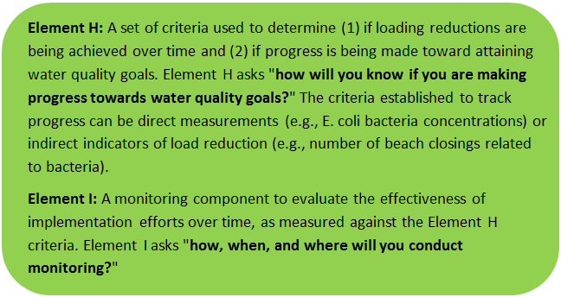 | 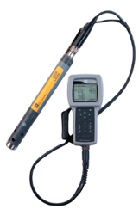

The water quality target concentration(s) is presented under Element A of this plan. To achieve this target concentration, the annual loading must be reduced to the amount described in Element B. Element C of this plan describes the various management measures that will be implemented to achieve this targeted load reduction. The evaluation criteria and monitoring program described will be used to measure the effectiveness of the proposed management measures (described in Element C) in improving the water quality of the Fort River.

Indirect Indicators of Load Reduction

Non-Structural BMPs
Potential load reductions from non-structural BMPs (i.e., street sweeping and catch basin cleaning) can be estimated from indirect indicators, such as the number of miles of streets swept or the number of catch basins cleaned. Appendix F of the 2016 Massachusetts Small MS4 General Permit provides specific guidance for calculating phosphorus removal from these practices. As indicated by Element C, it is recommended that potential phosphorus removal from these ongoing actives be estimated. Next, it is recommended that ongoing activities be evaluated to see if potential improvements can be implemented to achieve higher pollutant load reductions such as increased frequency or improved technology.
Phosphorus load reductions can be estimated in accordance with Appendix F of the 2016 Massachusetts Small MS4 General Permit as summarized by Figure HI-1 and HI-2.
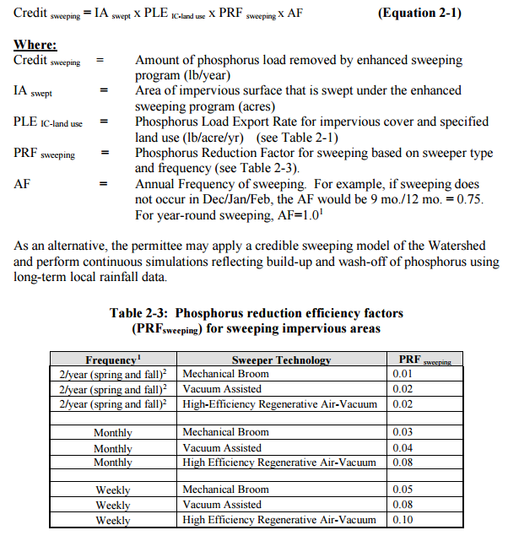
Figure HI-1. Street Sweeping Calculation Methodology
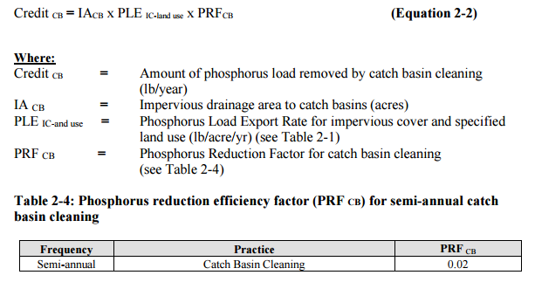
Figure HI-2. Catch Basin Cleaning Calculation Methodology

Project-Specific Indicators

Number of BMPs Installed and Pollutant Reduction Estimates:
Anticipated pollutant load reductions from existing, ongoing (i.e., under construction), and future BMPs will be tracked as BMPs are installed. For example, once ongoing BMPs are installed, the anticipated phosphorus load reduction for the Full of Grace Farm installation is estimated to be 665 pounds per year.

TMDL Criteria
TMDL requirements encourage ongoing monitoring to assess progress towards the TMDL’s water quality goals. The TMDL indicates that pilot projects should include monitoring to assess their effectiveness at removing phosphorus. Mill River (MA34-25) will be included in the upcoming “Massachusetts Statewide TMDL for Pathogen-Impaired Inland Freshwater Rivers” which is currently being drafted.

Direct Measurements
Direct measurements are generally expected to be performed as described below. Prior to implementing a direct measurement program, an abbreviated QAPP and/or Standard Operating Procedures (SOPs) will be established to flesh out details of the program and establish best practices for sample collection and analysis. Water quality monitoring may be performed through a volunteer training program to save on costs in accordance with established practices for MassDEP’s environmental monitoring for volunteers.

River Sampling
Establish regular sampling to understand the water quality in Mill River Watershed, including determining sources for pollution and tracking achievements toward water quality goals, including analysis of E. coli, phosphorus, nitrogen, and turbidity. Additional parameters such as chlorophyll-a, dissolved oxygen, temperature, conductivity, pH, and flow rate could provide additional data for consideration. If possible, obtain sampling of the Mill River directly downstream of Full of Grace Farm to determine the impact of proposed BMPs within the watershed. Monitoring locations will be selected based on accessibility and representativeness and shall be appropriate to quantify water quality improvements in the watershed.

In-Lake Phosphorus and Water Quality Monitoring
Sampling programs specific for the ponds (e.g., Lake Warner, Puffers Pond) within the watershed could be established to more closely track the progress of water quality improvements towards water quality goals. Monitoring locations should at minimum include the outlet of the pond, tributaries, and the deepest “in-lake” location. It is recommended that sampling programs include analysis of E. coli, secchi disk transparency, phosphorus, chlorophyll-a, turbidity, temperature/oxygen profiles, and aquatic vegetation. These parameters will also enable tracking relative to Carlson’s state trophic index to evaluate improvements over time.

Adaptive Management
As discussed by Element B, the baseline monitoring program will be used to establish a long-term i.e., 10 year) E. coli and phosphorus load reduction goal (or other parameter(s) depending on results). Long-term goals will be re-evaluated at least once every three years and adaptively adjusted based on additional monitoring results and other indirect indicators. If monitoring results and indirect indicators do not show improvement to the E. coli and total phosphorus concentrations and other indicators (e.g., chlorophyll-a) measured within the watershed, the management measures and loading reduction analysis (Elements A through D) will be revisited and modified accordingly.

References
314 CMR 4.00 (2013). "Division of Water Pollution Control, Massachusetts Surface Water Quality Standards"
Cohen, A. J.; Randall, A.D. (1998). "Mean annual runoff, precipitation, and evapotranspiration in the glaciated northeastern United States, 1951-80." Prepared for United States Geological Survey, Reston VA.
Geosyntec Consultants, Inc. (2014). "Least Cost Mix of BMPs Analysis, Evaluation of Stormwater Standards Contract No. EP-C-08-002, Task Order 2010-12." Prepared for Jesse W. Pritts, Task Order Manager, U.S. Environmental Protection Agency
Geosyntec Consultants, Inc. (2015). "Appendix B: Pollutant Load Modeling Report, Water Integration for the Squamscott-Exeter (WISE) River Watershed."
Hashemi, M and Harper, M. (2018). “Reducing Nonpoint Source Pollution from Two Livestock Facilities through Implementation, Remediation, and Education of Selected BMPs”. Project Number: 16-09/319. Dates: 2016-2018.
Johnson, Jason. Friends of Lake Warner and the Mill River. (2019) “Mill River Monitoring Data” Message to Julia Keay, Geosyntec Consultants. 20 December 2019. E-mail.
King, D. and Hagan, P. (2011). "Costs of Stormwater Management Practices in Maryland Counties." University of Maryland Center for Environmental Science Chesapeake Biological Laboratory. October 11, 2011.
Leisenring, M., Clary, J., and Hobson, P. (2014). "International Stormwater Best Management Practices (BMP) Database Pollutant Category Statistical Summary Report: Solids, Bacteria, Nutrients and Metals." Geosyntec Consultants, Inc. and Wright Water Engineers, Inc. December 2014.
MassDEP (2001). "Total Maximum Daily Loads of Phosphorus for Selected Connecticut Basin Lakes "
MassDEP (2008). “Connecticut River Watershed, 2003 Water Quality Assessment Report”
MassDEP (2012). "Massachusetts Year 2012 Integrated List of Waters Final Listing of Massachusetts' Waters Pursuant to Sections 305(b), 314 and 303(d) of the Clean Water Act"
MassDEP (2016). "Massachusetts Year 2016 Integrated List of Waters Responses to Comments Pertaining to the Proposed Listing of the Condition of Massachusetts’ Waters Pursuant to Sections 305(b), 314 and 303(d) of the Clean Water Act"
MassDEP (2013). “Connecticut River Watershed 2008 DVM Water Quality Monitoring Data”.
MassDEP (2016a). "Massachusetts Clean Water Toolkit"
MassDEP (2016b). "Massachusetts Stormwater Handbook, Vol. 2, Ch. 2, Stormwater Best Management Practices"
MassGIS (1999). "Networked Hydro Centerlines" Shapefile
MassGIS (2001). "USGS Topographic Quadrangle Images" Image
MassGIS (2007). "Drainage Sub-basins" Shapefile
MassGIS (2009a). "Impervious Surface" Image
MassGIS (2009b). "Land Use (2005)" Shapefile
MassGIS (2013). "MassDEP 2012 Integrated List of Waters (305(b)/303(d))" Shapefile
Schueler, T.R., Fraley-McNeal, L, and K. Cappiella (2009). "Is impervious cover still important? Review of recent research" Journal of Hydrologic Engineering 14 (4): 309-315.
United States Bureau of Labor Statistics (2016). "Consumer Price Index"
United States Geological Survey (2016). "National Hydrography Dataset, High Resolution Shapefile"
University of Massachusetts, Amherst (UMass) (2004). "Stormwater Technologies Clearinghouse"
UMass (2019). “Implementation, Remediation, and Education of Selected Best Management Practices to Minimize the Environmental Impact of Two Equine Operations”
USDA NRCS and MassGIS (2012). "NRCS SSURGO-Certified Soils" Shapefile
USEPA (1986). "Quality Criteria for Water (Gold Book)" EPA 440/5-86-001. Office of Water, Regulations and Standards. Washington, D.C.
USEPA. (2010). "EPA's Methodology to Calculate Baseline Estimates of Impervious Area (IA) and Directly Connected Impervious Area (DCIA) for Massachusetts Communities."
Voorhees, Mark, USEPA. (2015). "FW: Description of additional modelling work for Opti-Tool Project" Message to Chad Yaindl, Geosyntec Consultants. 23 April 2015. E-mail.
Voorhees, Mark, USEPA. (2016a). "FW: EPA Region 1 SW BMP performance equations" Message to Chad Yaindl, Geosyntec Consultants. 25 January 2016. E-mail.
Voorhees, Mark, USEPA. (2016b). "FW: Description of additional modelling work for Opti-Tool Project" Message to Chad Yaindl, Geosyntec Consultants. 23 April 2015. E-mail.

Appendix
Appendix A – Pollutant Load Export Rates (PLERs)
Land Use & Cover¹ | PLERs (lb/acre/year)
 | (TP) | (TSS) | (TN)
AGRICULTURE, HSG A | 0.45 | 7.14 | 2.59
AGRICULTURE, HSG B | 0.45 | 29.4 | 2.59
AGRICULTURE, HSG C | 0.45 | 59.8 | 2.59
AGRICULTURE, HSG D | 0.45 | 91.0 | 2.59
AGRICULTURE, IMPERVIOUS | 1.52 | 650 | 11.3
COMMERCIAL, HSG A | 0.03 | 7.14 | 0.27
COMMERCIAL, HSG B | 0.12 | 29.4 | 1.16
COMMERCIAL, HSG C | 0.21 | 59.8 | 2.41
COMMERCIAL, HSG D | 0.37 | 91.0 | 3.66
COMMERCIAL, IMPERVIOUS | 1.78 | 377 | 15.1
FOREST, HSG A | 0.12 | 7.14 | 0.54
FOREST, HSG B | 0.12 | 29.4 | 0.54
FOREST, HSG C | 0.12 | 59.8 | 0.54
FOREST, HSG D | 0.12 | 91.0 | 0.54
FOREST, HSG IMPERVIOUS | 1.52 | 650 | 11.3
HIGH DENSITY RESIDENTIAL, HSG A | 0.03 | 7.14 | 0.27
HIGH DENSITY RESIDENTIAL, HSG B | 0.12 | 29.4 | 1.16
HIGH DENSITY RESIDENTIAL, HSG C | 0.21 | 59.8 | 2.41
HIGH DENSITY RESIDENTIAL, HSG D | 0.37 | 91.0 | 3.66
HIGH DENSITY RESIDENTIAL, IMPERVIOUS | 2.32 | 439 | 14.1
HIGHWAY, HSG A | 0.03 | 7.14 | 0.27
HIGHWAY, HSG B | 0.12 | 29.4 | 1.16
HIGHWAY, HSG C | 0.21 | 59.8 | 2.41
HIGHWAY, HSG D | 0.37 | 91.0 | 3.66
HIGHWAY, IMPERVIOUS | 1.34 | 1,480 | 10.2
INDUSTRIAL, HSG A | 0.03 | 7.14 | 0.27
INDUSTRIAL, HSG B | 0.12 | 29.4 | 1.16
INDUSTRIAL, HSG C | 0.21 | 59.8 | 2.41
INDUSTRIAL, HSG D | 0.37 | 91.0 | 3.66
INDUSTRIAL, IMPERVIOUS | 1.78 | 377 | 15.1
LOW DENSITY RESIDENTIAL, HSG A | 0.03 | 7.14 | 0.27
LOW DENSITY RESIDENTIAL, HSG B | 0.12 | 29.4 | 1.16
LOW DENSITY RESIDENTIAL, HSG C | 0.21 | 59.8 | 2.41
LOW DENSITY RESIDENTIAL, HSG D | 0.37 | 91.0 | 3.66
LOW DENSITY RESIDENTIAL, IMPERVIOUS | 1.52 | 439 | 14.1
MEDIUM DENSITY RESIDENTIAL, HSG A | 0.03 | 7.14 | 0.27
MEDIUM DENSITY RESIDENTIAL, HSG B | 0.12 | 29.4 | 1.16
MEDIUM DENSITY RESIDENTIAL, HSG C | 0.21 | 59.8 | 2.41
MEDIUM DENSITY RESIDENTIAL, HSG D | 0.37 | 91.0 | 3.66
MEDIUM DENSITY RESIDENTIAL, IMPERVIOUS | 1.96 | 439 | 14.1
OPEN LAND, HSG A | 0.12 | 7.14 | 0.27
OPEN LAND, HSG B | 0.12 | 29.4 | 1.16
OPEN LAND, HSG C | 0.12 | 59.8 | 2.41
OPEN LAND, HSG D | 0.12 | 91.0 | 3.66
OPEN LAND, IMPERVIOUS | 1.52 | 650 | 11.3
¹HSG = Hydrologic Soil Group

Watersheds are defined by the WBP-tool by utilizing MassGIS drainage sub-basins.
Guidance on funding sources to address nonpoint source pollution: http://prj.geosyntec.com/prjMADEPWBP_Files/Guide/Element%20D%20-%20Funds%20and%20Resources%20Guide.pdf
Additional guidance is provided at: https://www.epa.gov/sites/production/files/2015-06/documents/stream.pdf and https://www.mass.gov/guides/water-quality-monitoring-for-volunteers#2
Additional guidance is provided at: https://www.epa.gov/sites/production/files/2015-06/documents/lakevolman.pdf

